

Guideline for Continuously Operating Reference Stations

Special Publication 1

(ICSM)

Permanent Committee on Geodesy (PCG)

24 September 2014

Document History

|  |  |  |  |  |
| --- | --- | --- | --- | --- |
| DATE | VERS | ISSUE | AMENDMENTS | AUTHOR(S) |
| 24/10/2013 | 2 | 0 | Document available | ICSM Permanent Committee on Geodesy |
| 24/09/2014 | 2 | 1 | Copyright updated | ICSM Permanent Committee on Geodesy |
|  |  |  |  |  |

cid:image003.jpg@01CFCD16.091A3200

© Commonwealth of Australia (ICSM) 2014

With the exception of the ICSM logo and where otherwise noted, all material in this publication is provided under a Creative Commons Attribution 3.0 Australia Licence (<http://www.creativecommons.org/licenses/by/3.0/au/>)

Table of contents

Document History ii

Table of contents iii

List of figures v

List of tables v

Terms and definitions vi

1 About this Guideline 8

1.1 Introduction 8

1.2 Normative references 8

2 Summary of recommendations for CORS 11

3 The CORS hierarchy 13

3.1 Tier 1 CORS 13

3.2 Tier 2 CORS 13

3.3 Tier 3 CORS 13

4 CORS network design 14

5 CORS establishment 15

5.1 Signal quality 15

5.1.1 Sky visibility 16

5.1.2 Multipath 16

5.1.3 Radio frequency interference sources 16

5.1.4 Pre-installation data quality assessment 17

5.2 Permission to build 17

5.3 Site access 17

5.4 Site security 18

5.4.1 Site identification and contact information 19

5.5 Site stability 20

5.5.1 Monument foundation 20

5.5.2 Antenna monument 21

5.5.3 Antenna mounts 25

5.6 Power and communications 26

5.6.1 Power supply 26

5.6.2 Communications 28

6 GNSS equipment 30

6.1 GNSS receiver 30

6.2 GNSS antenna 32

6.3 Antenna cable 34

6.4 Meteorological and other sensors 36

6.5 Pre-assembly 36

7 CORS coordination 37

7.1 Coordinate certification 37

7.2 Differences between CORS coordinates and survey control mark coordinates 37

7.3 Connection to the local survey control 38

7.3.1 Connection to GDA94 38

7.3.2 Connection to Australian Height Datum 39

7.4 Regional and network monitoring 40

8 CORS operation 41

8.1 Operational status 41

8.2 Data reliability 41

8.3 GNSS data formats 42

8.3.1 Post-processed data formats 42

8.3.2 Real-time data formats 42

8.4 Meteorological and other sensor data 43

8.5 Metadata 43

List of figures

Figure 1: Locked box enclosure at a sample Tier 2 site 18

Figure 2: Sample building enclosure at a sample Tier 3 site 19

Figure 3: Solar panel acting as a shade awning at a sample Tier 2 site 19

Figure 4: Example of monument inscription plaques 20

Figure 5: Sample Tier 1 and 2 CORS monuments 22

Figure 6: Sample Tier 3 CORS monuments 24

Figure 7: SCIGN antenna mount 25

Figure 8: SECO 2072 antenna mount 25

Figure 9: CORSnet-NSW adjustable antenna mount 25

Figure 10: Antenna mount for Tier 2 AuScope CORS, under construction 26

Figure 11: Power options; solar primary installation and pack-up battery installation 27

Figure 12: Connecting CORS sites with the survey control mark network 38

List of tables

Table 1: Summary of CORS Tiers recommendations 11

Table 2: Elevation mask recommendations 16

Table 3: GNSS receiver recommendations 30

Table 4: GNSS antenna recommendations 33

Table 5: Standard antenna cable recommendations 35

Table 6: Recommended requirements for CORS reliability 42

Terms and definitions

For the purpose of this Guideline, the terms and definitions listed below and those listed in the *Standard for the Australian Survey Control Network – Special Publication 1, Version 2.1* apply.

|  |  |
| --- | --- |
| Term/Acronym | Definition |
| APC | Antenna Phase Centre – the point inside a GNSS antenna to which all GNSS signals are measured. As it is not possible to physically measure this position, measurements should be made to the Antenna Reference Point (ARP) using the known offset between the APC and the ARP. |
| APREF | Asia-Pacific Reference Frame – a project to create and maintain an accurate and densely realised geodetic framework, based on continuous observation and analysis of GNSS data in the Asia-Pacific region. |
| ARP | Antenna Reference Point – the physically accessible point on a GNSS antenna to which all measurements related to that antenna are referred. |
| AuScope | An Australian federal program funded by the National Collaborative Research Infrastructure Strategy (NCRIS). A component of this program is the installation of up to 100 GNSS CORS and other geodetic technology for an increased understanding of the Australian tectonic plate and improvement of the national geodetic reference frame. |
| DOMES | Directory of MERIT Sites – historically, the DOMES numbering system was designed at the start of the MERIT campaign in the early 1980s in order to give an unambiguous identifier to all instrument reference points and markers. Since 1988, a DOMES number has been issued for all stations contributing to the ITRF. |
| Elevation mask | A GNSS receiver setting that determines whether GNSS signals are recorded below a certain angle above the horizon. |
| IGS | International GNSS Service - An international federation of agencies that pool resources to operate a global CORS network whose data is used, amongst other purposes, to generate precise GNSS products in support of Earth science research. |
| Multipath | Errors in GNSS observations caused by reflected GNSS signals interfering with the direct GNSS signal because of their common time origin but different path lengths. |
| NGS | [National Geodetic Survey](http://www.ngs.noaa.gov/): A United States of America Federal agency that manages the national coordinate system and a GNSS antenna calibration service. |
| NMS | Network Management System – a combination of hardware and software that monitors the components of a computer network and informs an operator whenever an outage occurs. |
| NTRIP | RTCM-Special Committee 10410.x Standard for *Networked Transport of RTCM via Internet Protocol* is an application-level protocol for streaming GNSS data over the Internet. |
| PDU | Power Distribution Unit – a device that manages the distribution of power to network components. |
| Regulation 13 | The process of verification of a reference standard of a position-measurement in accordance with Regulation 13 of the National Measurement Regulations 1999 and the National Measurement Act 1960. Through this process, Geoscience Australia certifies the position of a GNSS CORS, stated on the Regulation 13 certificate. |
| RFI | Radio Frequency Interference – interference of GNSS signals in the presence of other radio frequency signals, causing an adverse effect on the GNSS signals recorded at a site. Common sources of RFI can include radio and television towers, microwave data links, power lines or transformers, and mobile phone towers. |
| RINEX | Receiver INdependent EXchange: An internationally accepted format for the exchange of GNSS data between software applications and for GNSS data archiving. |
| RTCM | Radio Technical Commission for Maritime Services – Special Commission 104 is responsible for international standards of radio communication and navigation using differential GNSS. |
| SNR | Signal to Noise Ratio – a ratio of the amplitude of a wanted signal (c) to all unwanted signals (noise). |
| TEQC | A GNSS tool developed by UNAVCO for translating, editing and quality checking GNSS files. |
| Tier | A term used to differentiate GNSS CORS sites based on their reliability and contribution to reference frame definition and realisation. |
| UNAVCO | University NAVSTAR Consortium - A non-profit, membership-governed university consortium facilitating geoscience research and education using geodesy. |
| UPS | Uninterruptible Power Supply – an electrical device that provides short term power to devices when the primary power supply fails. |

# About this Guideline

## Introduction

The availability of accurate and reliable information relating to the position and uncertainty of Australia’s survey control marks is critical to the integrity of the National Geospatial Reference System (NGRS). The purpose of this Guideline is to promote the adoption of uniform procedures for the design, installation and operation of Continuously Operating Reference Stations (CORS) and the use of CORS to improve datums.

The delivery of NGRS is shifting from the sole use of traditional passive ground survey control marks to a method that combines these marks with active CORS based on Global Navigation Satellite System (GNSS) technology. The use of CORS for datum delivery is discussed in the document *Active GPS and Survey Marks* (ICSM, 2008).

In a geodetic context, CORS form an integral component of the nation’s geospatial infrastructure. The primary purpose of geodetic CORS is to collect data to measure and monitor the movement of the continent so that the reference frame and datum can be defined, improved, and maintained for geoscience and spatial datasets. CORS also support additional downstream applications such as major infrastructure projects, asset management, resource and emergency management, machine guidance, intelligent transport systems, precision agriculture and environmental research.

Both public and private sectors are investing in CORS at the national, state, territory, and local level, often as part of a network providing real-time positioning services, for their own business objectives. The Intergovernmental Committee on Surveying and Mapping (ICSM) has recognised that clear guidance and practical coordination is required to build an effective partnership model for the unification of these CORS.

This Guideline outlines ICSM’s recommended procedures for the design installation and operation of CORS sites within the framework of the Australian Survey Control Mark Network.

## Normative references

This Guideline should be read in conjunction with the *Standard for the Australian Survey Control Network – Special Publication 1, Version 2.1* herein referred to as the Standard.

The following documents may have relevance to the application of this Guideline.

**International Guidelines**

JCGM 100:2008, *Evaluation of Measurement Data – Guide to the Expression of Uncertainty in Measurement*, Joint Committee for Guides in Metrology – Bureau International des Poids et Mesures, Paris, France.

**SP1 Standard**

ICSM (2014), *Standard for the Australian Survey Control Network – Special Publication 1 Version 2.1*, Intergovernmental Committee on Surveying and Mapping, Canberra, Australia.

**SP1 Guidelines**

ICSM (2014), *Guideline for the Adjustment and Evaluation of Survey Control*, Version 2.1, Intergovernmental Committee on Surveying and Mapping, Canberra, Australia.

ICSM (2014), *Guideline for Control Surveys by Differential Levelling*, Version 2.1, Intergovernmental Committee on Surveying and Mapping, Canberra, Australia.

ICSM (2014), *Guideline for Control Surveys by GNSS*, Version 2.1, Intergovernmental Committee on Surveying and Mapping, Canberra, Australia.

ICSM (2014), *Guideline for Conventional Traverse Surveys,* Version 2.1,Intergovernmental Committee on Surveying and Mapping, Canberra, Australia.

ICSM (2014), *Guideline for the Installation and Documentation of Survey Control Marks*, Version 2.1, Intergovernmental Committee on Surveying and Mapping, Canberra, Australia.

**ICSM Technical Manuals**

ICSM (2006), *Geocentric Datum of Australia Technical Manual,* Intergovernmental Committee on Surveying and Mapping, Canberra, Australia.

ICSM (2007), *Australian Tides Manual – Special Publication 9,* Intergovernmental Committee on Surveying and Mapping, Wollongong, Australia.

**Technical Publications**

Brown, N. J., Featherstone, W. E., Hu, G. and Johnston, G. (2011), *AUSGeoid09: a more direct and more accurate model for converting ellipsoidal heights to AHD heights*, Journal of Spatial Science, 56:1, pp. 27 – 37.

Dawson, J. and Woods, A. (2010), *ITRF to GDA94 coordinate transformations*, Journal of Applied Geodesy, 2010 4:4, pp. 189–199.

ICSM (2008), *Active GPS and Survey Marks,* Intergovernmental Committee on Surveying and Mapping, Canberra, Australia. Available online:   
<http://www.icsm.gov.au/publications/ActiveGPSAndSurveyMarks.pdf>

Rizos, C. (2008), *Multi-constellation GNSS/RNSS from the perspective of high accuracy users in Australia*, Journal of Spatial Sciences, Vol. 53, No. 2, December, pp. 29-63.

**Other Publications**

The information in this Guideline has been adapted for Australian requirements drawing on information contained in the following documents:

Geoscience Australia (2013), Regulation 13 Certificates. Available online: <http://www.ga.gov.au/earth-monitoring/geodesy/regulation-13-certificates.html>

IGS (2007), *IGS site guidelines*, International GNSS Service. Available online: <http://igscb.jpl.nasa.gov/network/guide_igs.html>

IGS (2013a), *GPS and GLONASS antenna corrections*, International GNSS Service. Available online: <http://igs.org/igscb/station/general/igs08.atx>

IGS (2013b), *Naming conventions for IGS equipment*, International GNSS Service. Available online: <ftp://igscb.jpl.nasa.gov/igscb/station/general/rcvr_ant.tab>

IGS (2013c), *IGS site guidelines*, International GNSS Service. Available online: <http://igscb.jpl.nasa.gov/network/guidelines/guidelines.html>

IGS (2013d), *IGS formats*, International GNSS Service. Available online: <http://igscb.jpl.nasa.gov/components/formats.html>

IGS (2013e), *IGS blank site information form*, International GNSS Service. Available online: <http://igscb.jpl.nasa.gov/igscb/station/general/blank.log>

IGS (2013f), *Instructions for filling out site logs*, International GNSS Service. Available online: <http://igscb.jpl.nasa.gov/igscb/station/general/sitelog_instr.txt>

LINZ (2008), *Draft Specifications for the Installation of GNSS Continuous Tracking Stations*, Land Information New Zealand. Available online: <http://www.linz.govt.nz/docs/surveysystem/geodetic/gnss-continuous-tracking-station.pdf>

NGS (2006), *Guidelines for New and Existing Continuously Operating Reference Stations (CORS)*, National Geodetic Survey, National Oceanic and Atmospheric Administration. Available online: <http://www.ngs.noaa.gov/PUBS_LIB/CORS_guidelines.pdf>

NGS (2013), *Individual Antenna Calibrations*, National Geodetic Survey, National Oceanic and Atmospheric Administration. Available online: <http://www.ngs.noaa.gov/ANTCAL/>

RTCM (2011), *RTCM Online Publication Order Forms*, Radio Technical Commission for Maritime Services. Available online: <https://ssl29.pair.com/dmarkle/puborder.php?show=3>

SOPAC (2013), *Site log check*, Scripps Orbit and Permanent Array Centre. Available online: <http://sopac.ucsd.edu/scripts/checkSiteID.cgi>

UNAVCO (2012), *UNAVCO Knowledgebase – Power – Calculations for Solar Arrays and Battery Backup*, University NAVSTAR Consortium. Available online: <http://facility.unavco.org/kb/questions/463/Power+-+Calculations+for+Solar+Arrays+and+Battery+Backup>

UNAVCO (2013), *UNAVCO Knowledgebase – GNSS Permanent Stations,* University NAVSTAR Consortium. Available online: <http://facility.unavco.org/kb/categories/GNSS+Permanent+Stations/>

UNAVCO (2013), *TEQC,* University NAVSTAR Consortium. Available online: <http://facility.unavco.org/software/teqc/teqc.html>

# Summary of recommendations for CORS

Table 1 provides a summary of the recommendations provided in this Guideline.

Table : Summary of CORS Tiers recommendations

|  |  |  |  |
| --- | --- | --- | --- |
| **Recommendation** | **Tier 1** | **Tier 2** | **Tier 3** |
| Foundation: | | | |
| Bedrock or mass concrete base | ■ | ■ | □ |
| Competent rock through layers of soil or fractured rock | ■ | ■ | □ |
| Mounted on buildings or similar structures | X | X | ■ |
| Monumentation: | | | |
| Reinforced concrete pillar | ■ | ■ | □ |
| Stainless steel or galvanised mild steel mounts attached to building or concrete plinth | X | X | ■ |
| Interference: | | | |
| Minimum sky obstruction | ■ | ■ | ■ |
| Minimise multipath sources | ■ | ■ | ■ |
| Long-term site tenure | ■ | ■ | ■ |
| Power: | | | |
| Ensure continuous operation of GNSS receiver | ■ | ■ | ■ |
| Ensure continuous operation of all communications devices | □ | □ | ■ |
| Communication: | | | |
| Support remote control and data access | ■ | ■ | ■ |
| Reliable and continuous, with a latency of less than 2 seconds from CORS to end user (when used for real-time positioning applications) | ■ | ■ | ■ |
| Receiver: | | | |
| Dual frequency code and carrier phase tracking | ■ | ■ | ■ |
| Continuous logging of raw GNSS data | ■ | ■ | ■ |
| Ability to store at least 60 days of raw data | ■ | ■ | □ |
| Ability to store at least 30 days of raw data | X | X | ■ |
| Continuous raw data streaming, RTCM at 1Hz | □ | □ | ■ |
| Antenna: | | | |
| Choke ring antenna | ■ | ■ | □ |
| Individually calibrated absolute antenna phase centre | ■ | ■ | □ |
| IGS calibrated absolute antenna phase centre | ■ | ■ | ■ |
| Weather Station: | | | |
| Pressure measurement accuracy better than ± 0.5 hPa | ■ | ■ | □ |
| Temperature measurement accuracy better than ± 1° C | ■ | ■ | □ |
| Relative Humidity measurement to better than ± 2% | ■ | ■ | □ |
| Coordination: | | | |
| Coordinates in national geodetic datum, derived by national processing centre through Regulation 13 Certification | ■ | ■ | ■ |
| Site Monitoring: | | | |
| Continuous monitoring with IGS sites | ■ | ■ | N/A |
| Periodic high precision, local monitoring survey | ■ | ■ | □ |
| Continuous monitoring within CORS network | □ | □ | ■ |
| Data Format: | | | |
| Raw Proprietary format for archiving | ■ | ■ | ■ |
| RINEX for post-processing | ■ | ■ | ■ |
| RTCM for real-time applications | □ | □ | ■ |
| Reliability: | | | |
| Require complete, continuous time series dataset for post-processing | ■ | ■ | □ |
| Short communication outages tolerated | ■ | ■ | X |
| Ensure continuous stream of data to support real-time positioning services | □ | □ | ■ |
| Metadata: | | | |
| Complete and current IGS site log including DOMES number | ■ | ■ | □ |
| Readily available site metadata | ■ | ■ | ■ |

**Legend**

■ Strongly Recommended X Not Recommended

□ Recommended N/A Not Applicable

# The CORS hierarchy

ICSM has adopted the hierarchy of CORS proposed by Rizos (2008) as the basis for differentiating between CORS. The tier status of a CORS is determined by the primary purpose for which the station has been established and the expected stability of the station monument.

## Tier 1 CORS

Tier 1 CORS require high stability monuments to support geoscientific research and global reference frame definition. These sites are established to support the International GNSS Service (IGS) or other equivalent ultra-high accuracy networks. The IGS site guidelines (IGS, 2007) provide guidelines for all CORS sites contributing data to IGS, and additional requirements for the IGS Reference Frame Sites, which are a subset of IGS sites that are used to determine the International Terrestrial Reference Frame (ITRF). Data from Tier 1 CORS sites should be submitted to IGS for global geodetic science and research purposes.

## Tier 2 CORS

Tier 2 CORS require high stability monuments, usually established by national geodetic agencies for the purpose of defining and maintaining national geodetic reference frames. These sites form the primary national GNSS network. Note that Tier 1 CORS sites are generally a subset of these Tier 2 stations, providing a tie between the national geodetic datum and the ITRF. Data from Tier 2 CORS should be made available to the relevant national, state or territory jurisdiction for the purpose of national geodetic reference frame realisation and improvement.

## Tier 3 CORS

Tier 3 CORS require stable monuments and are established by national, state, territory governments and/or commercial agencies for the purpose of densification of the national CORS network, often supporting real-time positioning applications. These stations generally operate in, and provide access to, the datum rather than define it.

# CORS network design

The key parameters in the design of a CORS network are:

* distance between the CORS;
* connection to the reference frame and / or national geodetic datum; and
* effect of a station outage on service delivery.

Typical CORS network inter-station distances are as follows:

**Tier 1 CORS**: 500 to 1500 kilometres

**Tier 2 CORS**: 80 to 500 kilometres

**Tier 3 CORS**: 20 to 80 kilometres

Co-location of Tier 1 or Tier 2 CORS with other geodetic, meteorological or research infrastructure (such as tide gauges, gravity sites, seismic stations, VLBI or SLR sites) is encouraged where possible.

Constructing a nominal 10% of stations in a Tier 2 or 3 CORS network to the standards of the next highest tier provides a link between the CORS network and the national and international reference frame, and improves national geodetic datum accuracy. Where there are less than 10 CORS in a planned network, at least one site should be constructed to the standards of the next highest tier.

#### Comments on Network Design for CORS used in Network RTK

The manufacturers of Network RTK software currently recommend a maximum inter-station distance of 70 kilometres for optimum performance.

Network RTK software generally continues to function when a single CORS is not available in the middle of a network, though performance and accuracy may deteriorate.

Failure of a CORS site on the perimeter of the network may disrupt service in a portion of the network. To reduce service disruption, additional CORS sites around the network perimeter are recommended. Alternatively, increased power and communication redundancy at perimeter sites may help minimise service disruption.

# CORS establishment

The nominated tier of a CORS site will determine the criteria for many aspects of the site selection process. Accordingly, CORS establishment guidelines are also categorised by tier.

Every CORS site will have site-specific issues to resolve. The general principles for the location and design of a CORS include:

* Antenna Reference Point (ARP) stability;
* signal quality and data completeness;
* a continuous and reliable power supply;
* a reliable communications system with minimum latency; and
* infrastructure that resists the ambient environmental and security conditions.

An initial desktop design process, followed by a site reconnaissance is strongly recommended. The desktop design and reconnaissance should identify:

* significant signal obstructions;
* potential multipath and Radio Frequency Interference (RFI) sources;
* access restrictions;
* access to available power and communications;
* cable length requirements;
* human, pest and environmental site security issues;
* tenure and land ownership;
* potential changes to sky visibility from tree growth and development at adjacent sites; and
* site foundation suitability (this may require additional geophysical or structural analysis).

## Signal quality

The performance of a CORS site is dependent on the quality of the signals received by the antenna. This section provides guidance on issues affecting signal quality at a CORS site. Section 5.1.4 outlines a basic process for testing signal quality at a site prior to construction.

### Sky visibility

CORS sites should have as few obstructions as possible above the local horizon, and no obstructions above 10° elevation. Table 2 outlines the recommended elevation masks.

Table : Elevation mask recommendations

|  |  |  |  |
| --- | --- | --- | --- |
| **Recommendation** | **Tier 1** | **Tier 2** | **Tier 3** |
| Elevation mask | 0° | 0° to 10° | |

### Multipath

Multipath occurs when GNSS satellite signals arrive at the antenna via a number of paths. The signal arrives once directly from the satellite, and then a number of additional times having reflected off other surfaces.

Multipath sources can be natural or artificial. Surfaces such as metal panels and signs, roofs, the walls of buildings and even mesh fencing strongly reflect radio signals at the frequencies used by GNSS. So too do water bodies and trees, especially when the canopy is wet. Avoid these reflective bodies at CORS sites as much as possible. Site designers should be especially careful when locating solar panels, which are known to generate strong multipath signals.

Suspected sources of multipath should be a minimum of 20 metres from the CORS antenna and below 5° elevation. GNSS data quality analysis can identify multipath as a function of satellite elevation, and help determine a suitable elevation mask for Tier 3 CORS.

### Radio frequency interference sources

Common sources of Radio Frequency Interference (RFI) include radio, television and mobile phone transmitters, microwave data links, power lines and transformers. Directional transmitters, particularly microwave data links pointing toward the CORS site, can cause significant RFI.

Among other parameters, the effect of RFI is a function of the frequency, radiated power, and distance to the source. The effect of RFI is significantly increased when the RFI is a harmonic of a GNSS signal frequency.

It is, therefore, difficult to define a safe operating distance from an RFI source. RFI can be difficult to confirm and specialist advice may be necessary if RFI is suspected. If RFI is confirmed, and cannot be mitigated at a proposed CORS site, an alternate CORS site should be sought.

Note that RFI not only affects the GNSS signals received at the antenna, but also the wireless (radio or mobile phone network) transmission of site data. Where a CORS site is transmitting data via radio link, the radio transmission may itself be a source of RFI on the GNSS signals at the antenna.

### Pre-installation data quality assessment

Prior to CORS construction, record GNSS data at the site to assess the likely data quality from the CORS. This might be done during site reconnaissance. Where possible use the planned equipment and equipment settings for the site. The antenna should be placed as close as possible to the intended CORS location.

Record a minimum of 48 hours of data at 1 Hz with an elevation mask set to 0°. Ensure that the receiver is not code smoothing the pseudo-range observations.

Analyse the data with suitable GNSS quality assessment software such as TEQC. Analyse the signal reception and quality parameters on all frequencies and observables. The recommended analysis includes:

* multipath with respect to elevation;
* ratio of recorded to available observations;
* number, elevation, and duration of loss of lock and cycle-slip events; and
* variation of signal-to-noise (SNR) with satellite elevation.

Compare the results between days to identify if systematic biases exist. Temporal analysis is useful in identifying RFI that produces systematic signal interruption or degradation between days.

## Permission to build

A range of federal, state, territory, and local government acts, regulations, and planning policies may apply to the planned CORS site. These include, but are not limited to jurisdictional environmental planning policies, local environmental plans and development applications, native title regulations, and cultural heritage acts. Assess the proposed site against these acts, regulations, and policies prior to undertaking any site work, including site assessment work such as geophysical borehole sampling. Seek written approval for site work before commencing construction. The location of any existing infrastructure such as underground pipes and cables should be determined prior to construction.

## Site access

Determine arrangements regarding emergency and periodic access to the site prior to construction. Details of contact officers, costs, access times, required notifications and special local arrangements should all be agreed and documented.

Special local arrangements may include the need for site briefings and inductions, security procedures, and requirements for the supervision of visitors. An assessment of ease of access during poor weather conditions is important. Easements for access may be required to guarantee access to CORS sites on private land.

## Site security

Site security includes protecting the CORS site and equipment from theft, vandalism, weather, lightning, animals and insects.

It also includes securing long-term tenure. When a ground-based government CORS site is established, the preferred form of land tenure is a survey reserve. Freehold title, long-term leases, and easements are effective ways of registering an interest over the site. Ensure that any defined period tenure agreement includes an option for continuance and transfer if there is a change of land or CORS ownership. Document any insurance requirements covering either party.

By its nature, a CORS site is exposed to weather and the natural environment. The Bureau of Meteorology can provide information on the seasonal weather patterns expected at a proposed site.

Electronic equipment not contained in a secure and weatherproof building may require a locked and sealed enclosure such as that shown in Figure 1, or in a building enclosure such as that shown in Figure 2. Use enclosures rated to industry standards for protection against ambient conditions and vandalism. These enclosures may need to include insulation, air conditioning or other equipment to control temperature and humidity. Locate equipment with the least tolerance of temperature extremes lower in the enclosure. Design solar panels and other external equipment to withstand local conditions. Solar panels can be used to shade the equipment enclosure as shown in Figure 3.

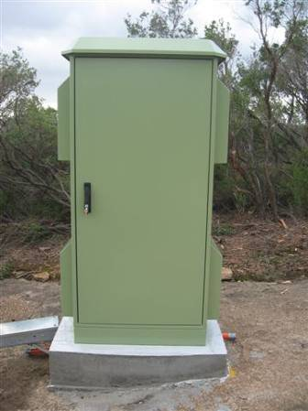 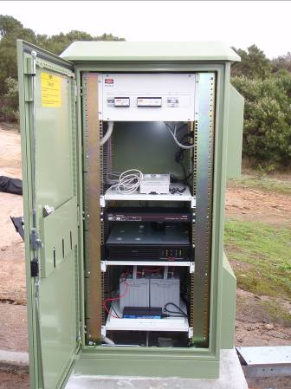 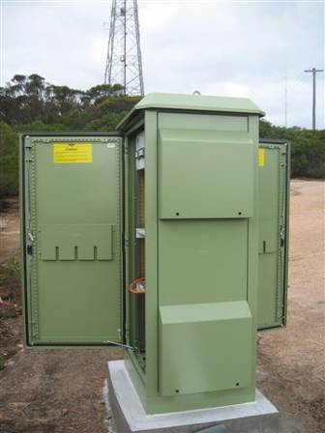

Figure : Locked box enclosure at a sample Tier 2 site

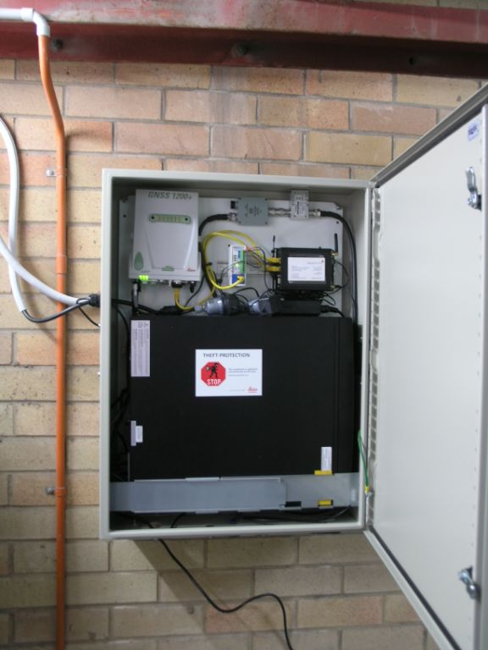

Figure : Sample building enclosure at a sample Tier 3 site

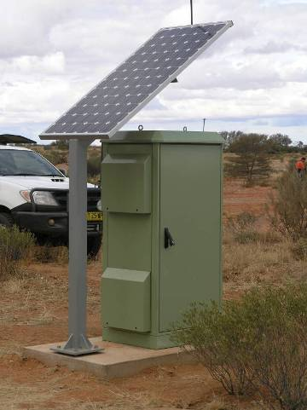

Figure : Solar panel acting as a shade awning at a sample Tier 2 site

### Site identification and contact information

It is recommended to install a monument inscription plaque on or very close to the GNSS antenna monument. This plaque should state the name of the GNSS CORS and provide brief contact details of the CORS operator. This information can serve to inform the general public of the importance of the infrastructure, as well as reinforce the importance of not inadvertently interfering with the installation. Examples of such plaques are provided in Figure 4.

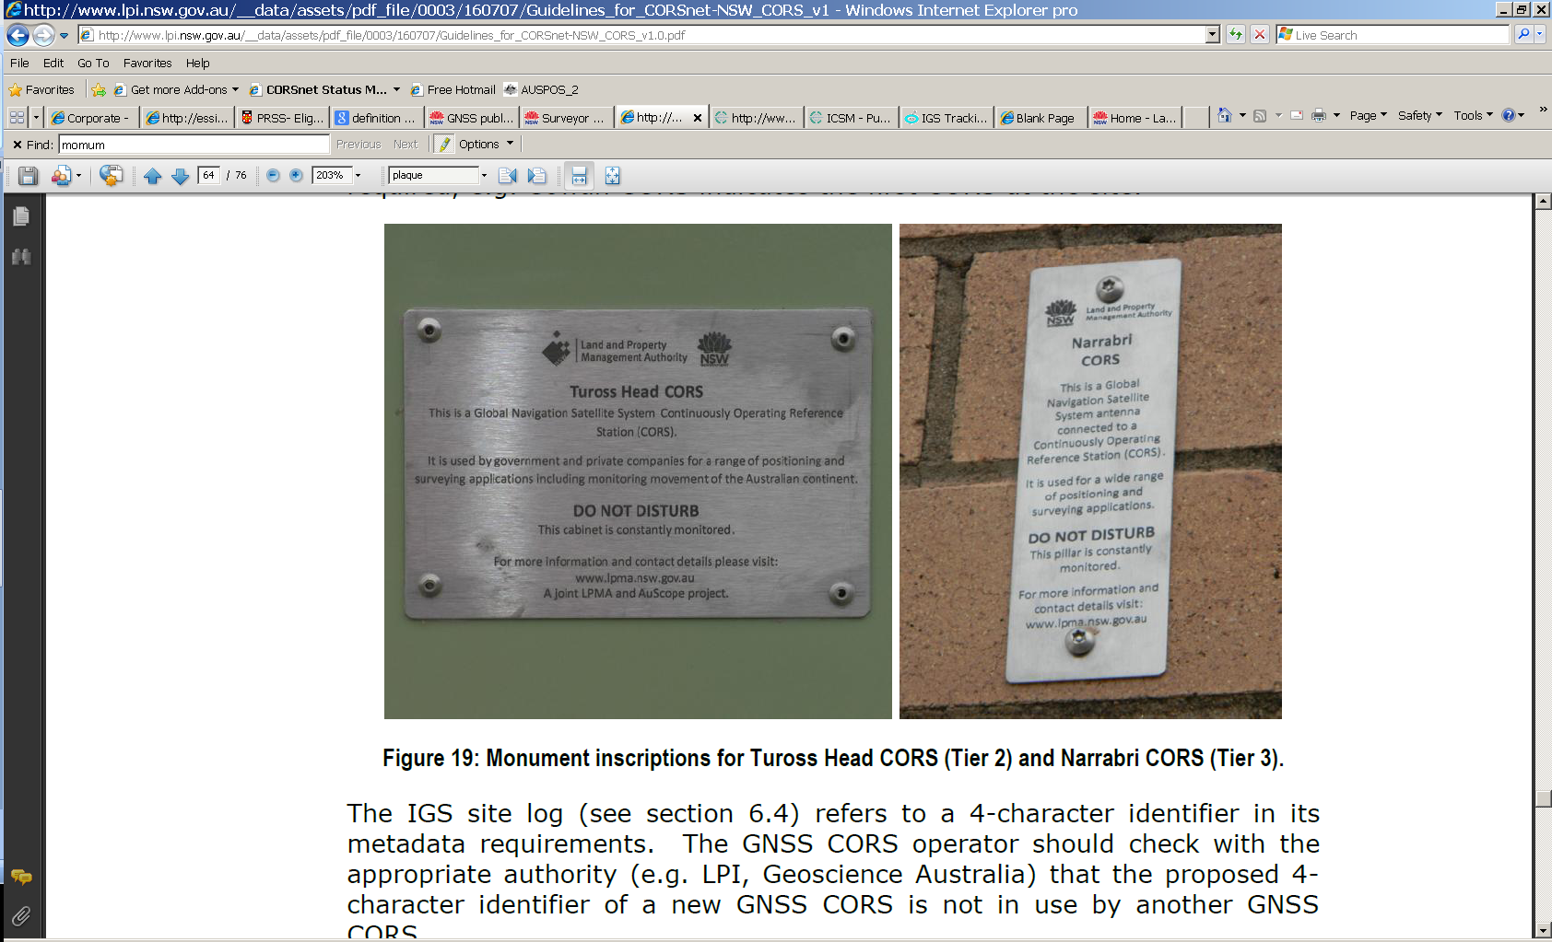

Figure : Example of monument inscription plaques

## Site stability

The primary factors affecting the stability of a CORS antenna are its foundation, its monument, and the antenna mounting device.

### Monument foundation

Ideally, Tier 1 and 2 antenna monuments should be structurally fixed to sound bedrock. This provides data on tectonic plate motion, related tidal forces, and allows a precise realisation of the national geodetic reference frame. A site with exposed bedrock is preferred. In cases where bedrock is more than 4 metres beneath the surface, a large concrete foundation may be used. Avoid sites with reactive soils or where surface cracking may indicate significant soil movement. Where there is concern about the foundation, geophysical testing is recommended.

Tier 3 CORS have greater design flexibility. This enables CORS operators to take advantage of available resources such as proximity to existing power and communications infrastructure, site security and site tenure. Tier 3 CORS sites may be fixed to bedrock, a concrete foundation in stable soil, and on load bearing components of concrete, brick, or masonry structures, preferably near the intersection of two walls. Due to thermal expansion and wind loading, structures less than ten metres in height are preferred.

Structures under variable loading, such as water towers and buildings undergoing post-construction settlement, may be used for Tier 3 CORS after extensive analysis has proven their stability. To reduce the effect of multipath from the building, avoid structures with metal cladding or roofs.

For all tiers, where doubt exists about the stability of the proposed foundation, structural analysis may identify the best foundation, monument type, mounting point, and fixing method.

### Antenna monument

For all CORS, the required characteristics of the monument include:

* short, medium, and long term stability;
* minimal multipath;
* sufficient height to minimise obstructions;
* true verticality within 1 mm (Tiers 1 and 2) or 5 mm (Tier 3);
* simple design for ease of manufacture, installation and maintenance;
* low maintenance;
* corrosion, erosion, and subsidence resistant;
* capable of bearing the mass of antenna; and
* tamper-proof design.

Monument design should be certified by a structural engineer. Observe all relevant building and construction codes and obtain any required permits and approvals.

The width of the top of the monument should be less than the antenna diameter to minimise multipath from the monument edge and upper surface.

In Australia, reinforced concrete pillars are preferred for Tier 1 and Tier 2 CORS sites. A monument height of between 1.2 and 1.7 metres is preferred to minimise the effect of multipath off ground surfaces.

Figure 5 shows two examples of Tier 1 and 2 CORS antenna monuments.

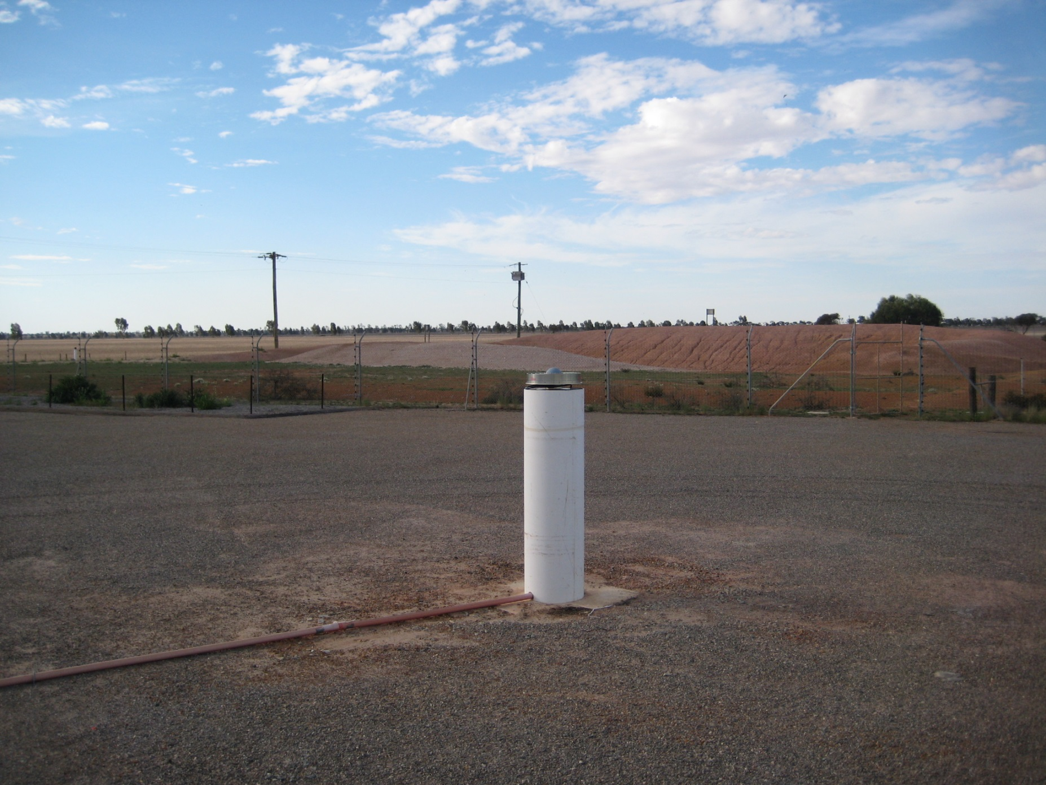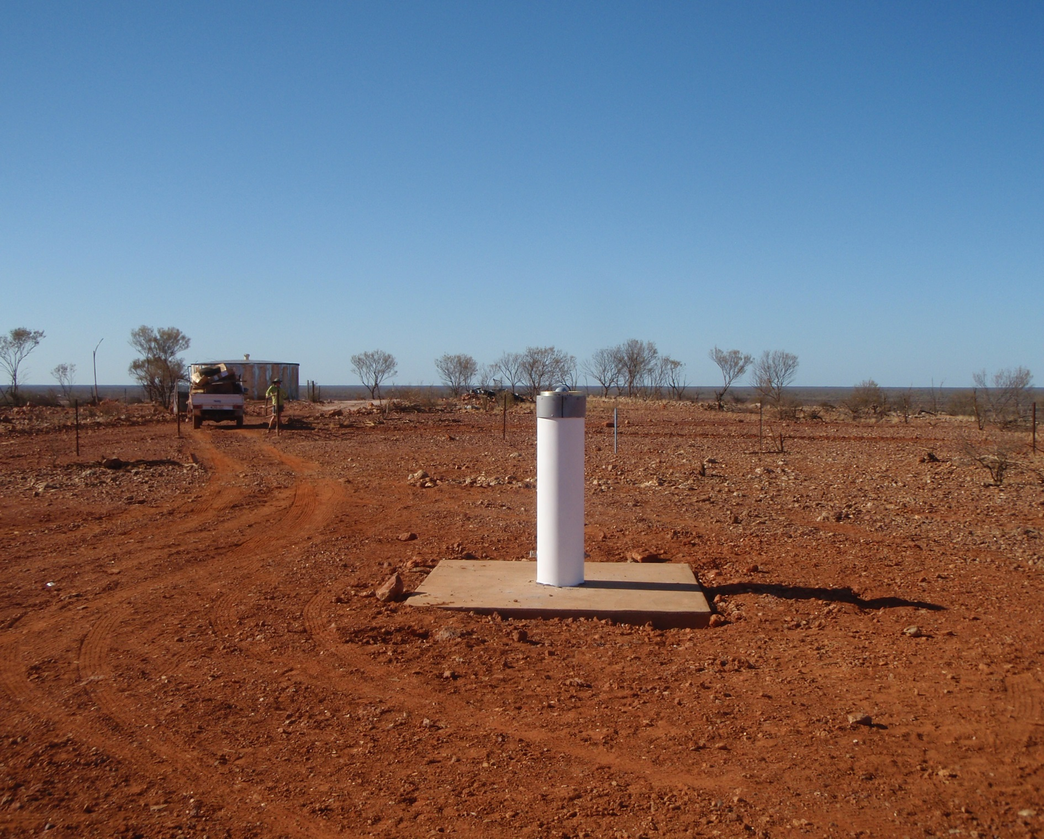

Figure : Sample Tier 1 and 2 CORS monuments

Ground based Tier 3 CORS sites may use pillars, deep-drilled braced monuments, or other purpose built monuments that provide suitable stability. Stainless steel (preferred) or galvanised mild steel is recommended for Tier 3 CORS mounted on buildings, posts, or mast and brace monuments. Avoid aluminium monuments due to the increased thermal expansion of aluminium. Roof monuments should place the antenna a minimum of 0.5 metres above the roof. Avoid structures with a metal roof where possible. If a structure with a metal roof or other reflective surface is used, avoid antenna heights that are multiples of GNSS carrier phase wavelengths (19 or 24 centimetres).

Customise the monument design of building based monuments to match the building’s construction. Monuments located near the corner of two existing, solidly constructed brick or concrete walls are recommended. Where possible keep fittings 0.5 metres from windows and wall edges. Ensure that the monument and fixings do not damage the foundation structure.

Use stainless steel bolts and fittings. Use through-bolts that penetrate the entire wall thickness for solid concrete walls unless the through bolt fitting will be exposed in an interior workspace such as an office or hallway. The use of stainless steel backing plates will help distribute the force of through bolts. Avoid through bolts on cavity walls, as this may pull the skins together and weaken the foundation structure.

Where fixtures do not entirely penetrate a foundation wall, use ChemSetTM stainless steel bolts penetrating at least half the wall width.

Ensure that sufficient safety provisions (harness points, ladder brackets etc.) are available for personnel installing or maintaining roof mounted monuments and equipment.

Figure 6 shows examples of Tier 3 bracketed, post, and post and stay CORS antenna monuments (courtesy Department of Sustainability and Environment, Victoria, Department of Natural Resources and Mines, Queensland, and Land and Property Information New South Wales).

#### Additional Information on CORS Antenna Monuments

Additional information on CORS antenna monuments is available from the resources:

* IGS Monumentation Design and Implementation Web page, available from: <http://igscb.jpl.nasa.gov/network/monumentation.html>
* NGS *National Continuously Operating Reference Station Monumentation Process Action Final Report*, available from: <http://facility.unavco.org/kb/getattachment.php?data=Mjg1fENPUlNfTW9udW1lbnRhdGlvbi5wZGY>
* UNAVCO Knowledgebase – GNSS Station Monumentation Web page, available from: <http://facility.unavco.org/kb/questions/104/UNAVCO+Resources%3A+GNSS+Station+Monumentation>

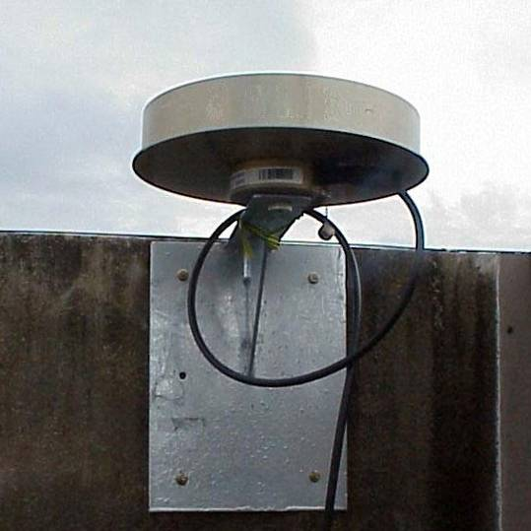 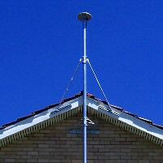

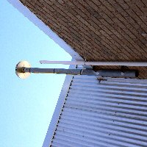 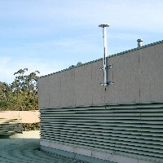

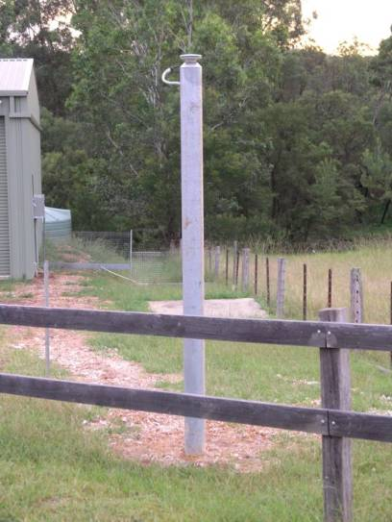 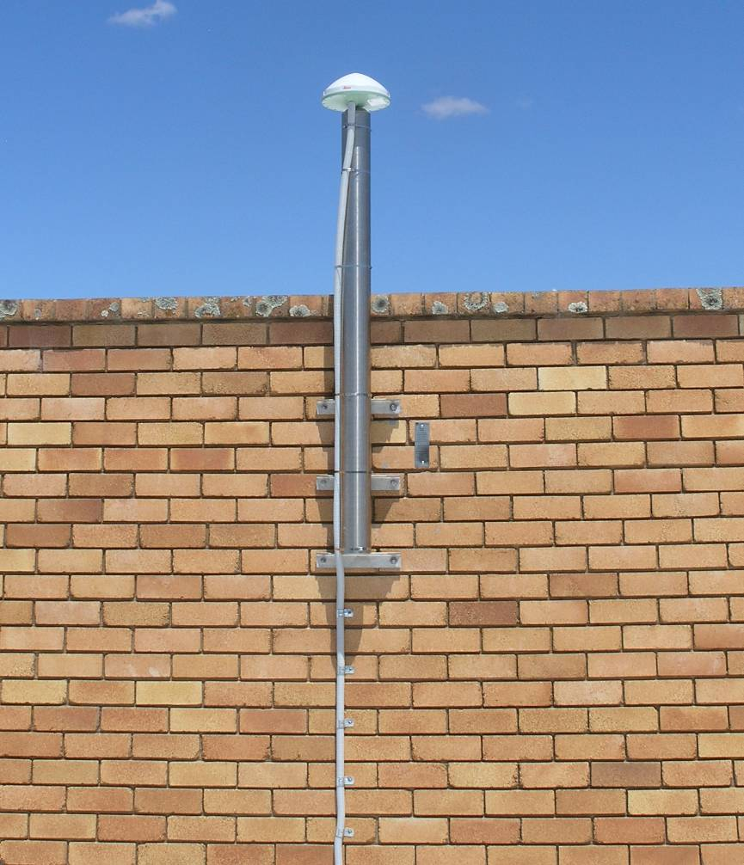

Figure : Sample Tier 3 CORS monuments

### Antenna mounts

The antenna mount connects the GNSS antenna to the monument. Once installed the antenna mount should lock the antenna in place so it cannot move or rotate. When an antenna is removed and replaced, the mount should return the antenna reference point to the same location and orientation. The antenna mount must maintain a level antenna, oriented to within 5° of true north for antenna calibrations to be effective. Using thin shims or washers allow the antenna to be oriented to true north, but will introduce a height of antenna that must be carefully communicated to data consumers to allow accurate positioning. Figure 7, Figure 8 and Figure 9 show some example CORS mounts. A survey tribrach is not considered an acceptable antenna mount.

|  |  |
| --- | --- |
| Figure : SCIGN antenna mount | Figure : SECO 2072 antenna mount |

Figure 9: CORSnet-NSW adjustable antenna mount

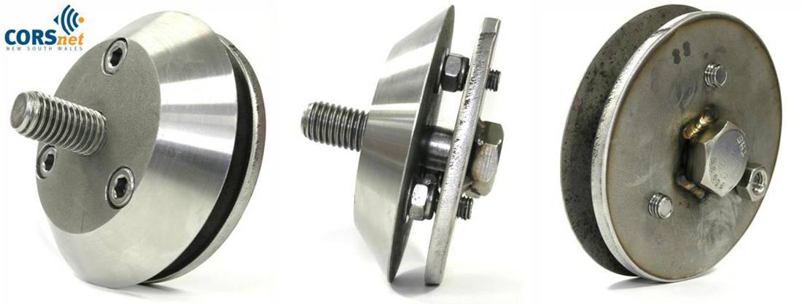

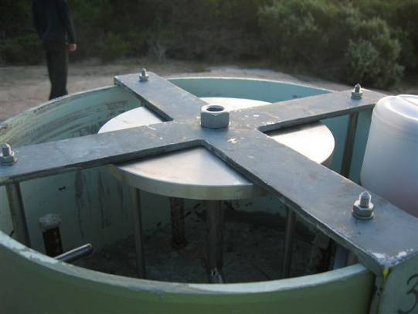 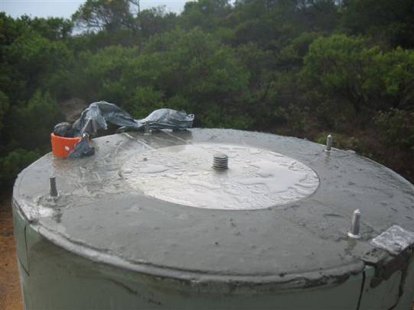

Figure : Antenna mount for Tier 2 AuScope CORS, under construction

## Power and communications

### Power supply

A CORS has a fundamental need for continuous and reliable power. A detailed analysis of the proposed CORS design, balancing peak and total power consumption with the available supply is a key to reliable CORS operation. Include a safety margin in the designed power supply. Specialist advice in the power system design is recommended.

Mains and solar power are both suitable primary power sources. The choice between solar and mains primary power is a balance of cost, security, availability, and location. A distant connection to the power grid may make solar power with a battery array a more economical choice. Unreliable mains power, with significant power fluctuations, may make solar power preferable, particularly in regional areas. Figure 11 shows a solar power installation and two equipment cabinets with deep cycle batteries in the base.

Where mains power is used, a dedicated power circuit for the CORS equipment is recommended to reduce the risk that power loads from other equipment may trip a circuit breaker or residual current device and interrupt the power to the CORS equipment. Install mains power outlets in a manner that minimises inadvertent or wilful disconnection of power to the site equipment. Surge protection to prevent damage from power spikes is recommended.

Available sunlight is the key factor for solar performance. This is a function of latitude and local climate conditions. Check with the Bureau of Meteorology for average hours of available sunlight in the target area. A number of site power calculators that help determine power consumption are available on the internet, including the UNAVCO CORS power calculator (UNAVCO, 2012).

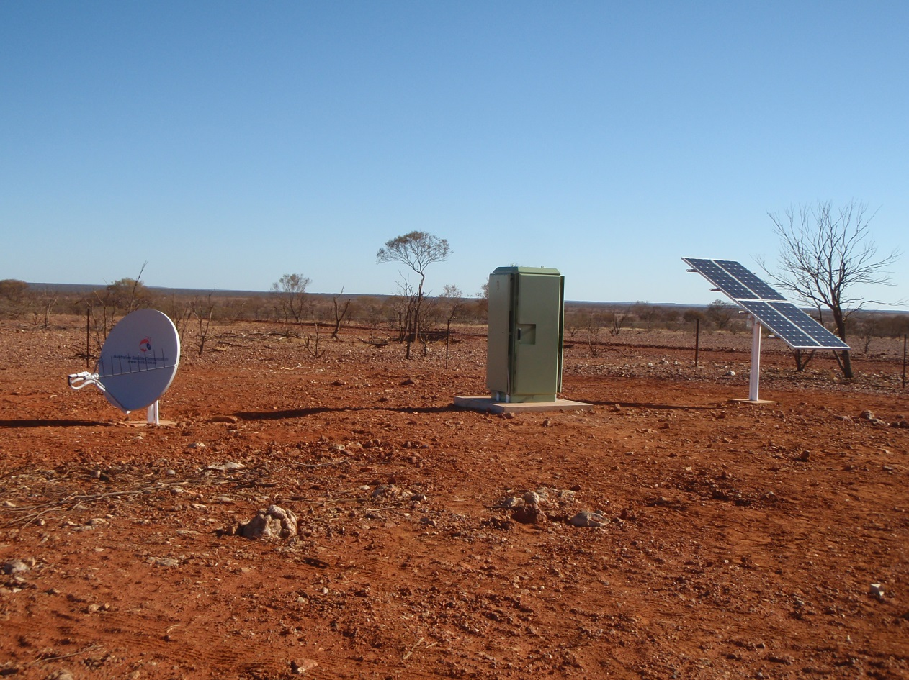

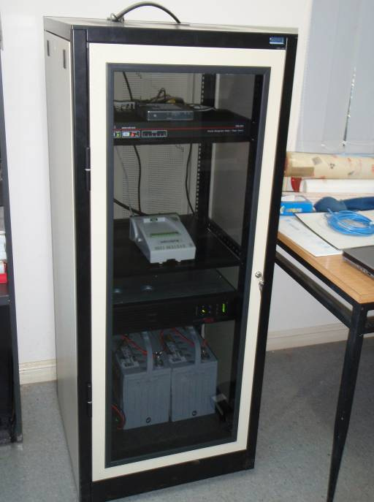 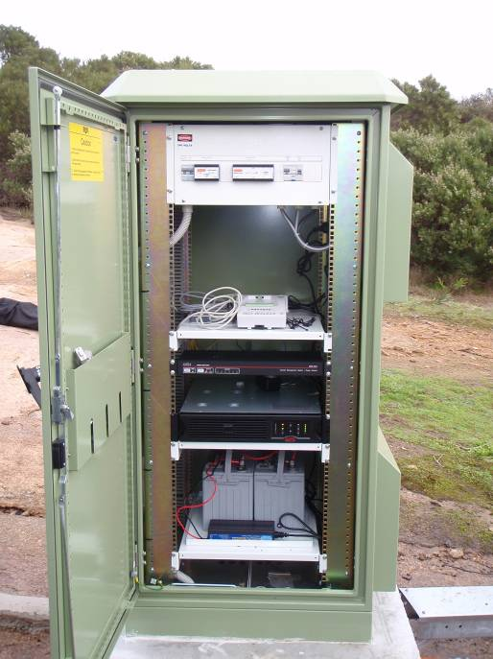

Figure : Power options; solar primary installation and pack-up battery installation

Dual (primary and secondary) power supplies are required for Tier 1 and 2 sites, and highly recommended for Tier 3 sites. At Tier 1 and 2 sites the secondary power supply should, at minimum, power the GNSS receiver, inline amplifiers, and automatic weather station for seven days. At more remote sites, the secondary power supply may need to power the site for a longer period to enable service or repair. Secondary power sources for sites providing real-time data will also need to power communications devices and other equipment. Cooling fans and switches will also increase the power requirement of the site. A secondary power source supplying seven days of power is also recommended for Tier 3 sites; however the length of time that a secondary source powers a Tier 3 site is an issue of risk mitigation for the operator.

A battery system is required for solar powered sites, and is a common secondary power supply for sites with mains primary power. An Uninterruptable Power Supply (UPS) is a common short term power source, providing power during the switchover between the primary and long term secondary power sources.

A Power Distribution Unit (PDU) is recommended for CORS sites. The PDU manages and conditions the power supply to the site, often with an automatic fall-over/fall-back mechanism to switch between primary and secondary power sources. A remotely managed PDU controls the power system within pre-set limitations and provides system tools, reports and alerts. Depending on the ambient conditions, a PDU may also switch less critical equipment off and back on again. A PDU with a communications link allows the CORS operator to control power to the equipment manually from a remote location.

The use of a Network Management System (NMS) is also recommended. An NMS is a communications device that monitors and manages the electronic equipment installed at a CORS site. It may detect when equipment is not responding, run diagnostics, provide alerts, and, if necessary, reboot a non-responsive device. This is useful at remote sites when the communications equipment is not responding correctly, and may resolve the problem without a site visit.

In the event of low power supply an integrated NMS, PDU and UPS arrangement can also ensure that critical equipment such as the GNSS receiver maintains power at the expense of powering less critical equipment. The reports from the site NMS and PDU can alert operators to equipment that is not performing as expected, providing an opportunity for replacement prior to failure.

### Communications

A CORS site requires reliable communications for data transmission, either directly to users, or to an intermediate network control centre. The design of this communications system is a core design issue affecting data transmission and remote control of the CORS equipment. The communications requirement is more closely related to whether the site provides data as a real-time stream and/or periodic download than the tier of the site. For all CORS, specialist advice is recommended in this critical system.

There are a range of communications options and service providers available. Common communications systems for data transmission between a CORS site and a network control centre include:

* ADSL (Asymmetric Digital Subscriber Line);
* mobile phone network;
* corporate WAN (Wide Area Network) between offices; and
* Very Small Aperture Terminal (VSAT) satellite link for remote locations

Direct communications from a CORS to a rover is often transmitted via conventional radio (typically UHF) or Internet radio.

Radio transmission of data should only be used to provide local real-time data services, and is not recommended as the primary communications method for Tier 1 and 2 CORS sites.

Communication system design depends on the data bandwidth required, data protocols used, acceptable latency of data, and the services available in the target area. A secondary independent communications system is recommended to improve site reliability. Secondary communications are important at sites offering real-time services, and at remote sites where the expense of a site visit is greater. For sites on the perimeter of a network RTK service, where site failure may lead to localised denial of service, secondary communications systems are highly recommended.

The bandwidth required for CORS data transmission is affected by a number of factors including:

* normal transmission operations (i.e. data streaming and regular data downloads);
* irregular downloads such as retrieving data stored on the receiver after a communications outage;
* uploads for receiver firmware upgrades;
* additional bandwidth loads such as Graphical User Interface support for GNSS receivers, meteorological stations, and network or power management devices; and
* increased overall data volumes due to GNSS modernisation (i.e. extra signals, satellites, and satellite systems).

Irrespective of the communications method used, data latency from a CORS site to the user for real-time positioning services should not exceed two seconds. Where real-time data is distributed to the user via a network control centre the data latency between the CORS site and the network control centre should be designed to be less than half a second. Latency between a CORS site and a network control centre is not only a function of the connection between the CORS and the server, but also includes the effect of additional data traffic from other devices on the network.

Mixed mode communications may be used at a CORS site if necessary. For example data may be sent from the CORS site via a radio link to a nearby, remotely located, reliable internet connection. Mixed mode connections may, however, increase data latency to end users.

In Australia, a licence to broadcast via radio may be required from the Australian Communications and Media Authority (ACMA).

Each CORS site will have site specific communications challenges. Where possible, however, a common approach using common components for CORS sites will simplify the maintenance and operation of CORS communication systems.

# GNSS equipment

GNSS technology is evolving at a rapid rate. New GNSS systems and signals, revised data formats and improving communications options all tend to shorten the equipment replacement cycle. A sustainable CORS operation is a balance between technology, cost, efficiency and demand.

## GNSS receiver

Table 3 provides recommendations for a CORS receiver as at the date of issue of these Guidelines. These recommendations apply to all tiers unless otherwise indicated. Some recommended capabilities may be optional, for example, radio capabilities may not be required if the CORS is not transmitting data over radio.

Table : GNSS receiver recommendations

|  |  |
| --- | --- |
| **Component** | **Recommended Minimum Capability** |
| Signal Tracking | * 12 channels per frequency per system tracked * Records all available carrier phase, pseudo-range, Doppler, and Signal-to-Noise Ratio (SNR) per tracked frequency * Ideally simultaneous GPS L2C and P2 tracking * Pseudo-range measurements should not be smoothed for RINEX * GPS and GLONASS tracking * Capability to observe future signals when available is an advantage * Receivers capable of tracking space-based augmentation services should have this function turned off |
| Internet Communications | * Dedicated Network (Ethernet) Port * Serial/USB port   • Static IP address  • HTTP/S interface  • ftp over Transfer Control Protocol (TCP)  • IP Configurable LAN/WAN connectivity |
| Radio Communications | * Radio output port capability (Tier 3 only) where required * 4,800 – 115,200 baud rate |
| Power | * Nominal 12 V DC input * Extended operational range between 10.5 and 28 V DC * Dual power inputs |
| Inputs | * External Frequency (Tier 1 and 2) * Meteorological Sensor (Tier 1 and 2) |
| Output | * Current RTCM SC-104 at 1 Hz on multiple ports * NMEA-0183 * Proprietary raw data streaming * Capable of streaming data to multiple locations * 1 Pulse Per Second (PPS) output (for timing applications) |
| Logging | * On-board continuous logging of raw unsmoothed data * On-board logging of data stored as 1 Hz hourly and 30 second daily RINEX files simultaneously * On-board logging of input sensor data |
| Internal Memory | * Capability to store at least 60 days (Tier 1 and 2) or 30 days (Tier 3) of raw and RINEX data on-board per the logging specification * Internal file memory management * USB storage devices may be used to extend the receivers logging capability |
| Environment | * Operating Temperature of -40° C to +65° C * Dustproof/waterproof to IP67 * Humidity MIL-STD 810F * Shock resistant to 1 m drop on hard surface |
| Remote Control Settings | * Full control of receiver functions via web based GUI including:   + Data protocols and logging rates   + Data transfers   + Quality settings   + Power cycling   + General system management   + Client access authentication   + Firmware upgrades |

The choice between using homogeneous or heterogeneous GNSS receivers in a network is a business decision for the operator. A single brand or model of GNSS receiver reduces the number of different pieces of equipment a network operator needs to be familiar with, possibly simplifying maintenance and operation. Conversely, if a single brand or model of GNSS receiver is used, and there is a fault in that brand/model’s hardware or firmware, the operator is at increased risk of network failure.

GNSS receiver firmware updates often include software patches or improved tracking or processing capabilities for the receiver. However, firmware should only be upgraded if changes are beneficial to the operation of the receiver, and only after thorough testing.

## GNSS antenna

An antenna calibration links the GNSS signal measurement point (the Antenna Phase Centre or APC) to the physical measurement point to which all antenna offsets are referred (the Antenna Reference Point or ARP). It is recommended that individual antenna calibrations are ideally sought for Tier 1 and 2 CORS. Within Australia, Geoscience Australia (GA) is able to provide individual calibration of Tier 1 and 2 sites through the robotic Antenna Calibration Facility (ACF), located in Canberra. As individual antenna calibrations may not be feasible, IGS provides ‘type’ (model specific) antenna calibrations free of charge (IGS, 2013a). For antenna calibrations to be valid the GNSS antenna must be orientated to within ±5° of True North. Relative antenna calibration models should not be used.

Choke ring antennas have very stable and well understood properties, with high multipath mitigation. These antennas are used for all GA ARGN and AuScope sites and are recommended for all Tier 1 and 2 CORS. Antennas with ground planes are recommended for CORS that do not use choke ring antennas.

The use of radomes is discouraged. Although they provide some level of protection from the elements, radomes alter the location of the APC. Even worse, as ultraviolet light affects the properties of the radome material, its impact on the APC's location varies. However, environmental conditions such as snowfall, sea spray or the likelihood that the antenna may be used as a perch for birds may require the use of a radome. In this case, the antenna/radome combination must have a valid antenna calibration. Conical radomes should not be used. Do not remove radomes from existing GNSS antennas.

When installed, a GNSS antenna should not be removed or replaced unless it is necessary (e.g. due to hardware failure). CORS metadata should be updated as soon as possible after any change to the antenna. Users and any analysis centres should be forewarned. Experience shows that when a GNSS antenna is removed and replaced there is a change in the computed position of the site, even when the ARP is replaced precisely. Therefore, do not remove the antenna for any reason other than hardware failure. Choose antennas that are capable of tracking as many planned GNSS signals as possible at the time of purchase to reduce the need to remove an antenna to track newly available GNSS signals. To avoid confusion, the IGS standard naming convention for antenna models (IGS, 2013b) must be used in site logs and metadata.

Table 4 provides recommendations for a geodetic quality CORS antenna at the date of issue of these Guidelines. These recommendations apply to all tiers unless otherwise indicated.

Table : GNSS antenna recommendations

|  |  |
| --- | --- |
| **Component** | **Recommended Minimum Capability** |
| Antenna Type | * Tier 1 and 2 sites shall have choke ring antennas, preferably with Dorne-Margolin elements. Dorne-Margolin elements are required at AuScope and ARGN sites. * Tier 3 CORS may use a choke ring or ground plane antenna. * Antenna satellite signal tracking capabilities should be matched with or exceed the capability of the GNSS receiver. |
| Antenna Phase Centre (APC) Calibration | * All Tier 1 and 2 CORS antennas shall have a valid IGS absolute antenna calibration (IGS, 2013a) or undergo individual antenna calibration. * An IGS antenna calibration is preferred for Tier 3 sites. NGS (2013) antenna calibration may be used at Tier 3 CORS with caution. * The source of the antenna calibration shall be noted in the station site log and metadata. |
| Antenna Reference Point (ARP) | * All antenna-offset measurements shall refer to the ARP. |
| Radome | * The use of antenna radomes is strongly discouraged. * If conditions require a radome, use a hemispherical radome/antenna combination with a valid absolute antenna calibration. * Do not remove radomes from existing sites unless antennas are replaced due to failure. * Conical radomes should not be used. |
| Antenna Orientation | * The antenna should be oriented to ±5° of True North. * If deflection from True North is greater than ±5° the actual alignment must be measured and recorded on the station site log and metadata. |
| Environmental | * Weatherproof and corrosion resistant. |

## Antenna cable

All CORS cabling is vulnerable to vandalism, weather, pests and fire. Protect external cabling in buried or secured conduits. Dedicated cableways are recommended within buildings. Cable connectors are potential points of failure when stressed, corroded, or infiltrated by water, dust and pests. Use self-amalgamating ultra-violet stabilised tape to protect cable connections.

Tension in the cable at the receiver and antenna connection may place stress on the connection causing failure or intermittent connection. At the antenna this tension may also cause the antenna to rotate. A short loop of excess cable at the antenna and receiver connections is recommended.

The quality of antenna cable is categorised by its rated signal loss per metre. Higher grade cables have less signal loss per linear metre at the expense of increased cost and decreased cable flexibility. Each connection along a cable increases the signal loss and adds a potential point of failure. Where inflexible high grade cables are used for the main cable run, a short flexible lead of lower grade cable may reduce stress on the antenna or receiver connection. An unstressed cable of minimum length with minimal connectors provides an optimal solution.

An in-line amplifier reduces signal loss to the receiver, but adds another point of failure. Use higher rated low-loss cable in preference to lower rated cables with in-line amplifiers. Antenna splitters should only be used when the CORS site includes a second, redundant, GNSS receiver, or for test purposes.

An in-line grounded lightning arrester between the antenna and receiver may protect the GNSS receiver and communications equipment in the event of a lightning strike, although the antenna is not protected. While lightning arrestors add a connection to the cable and induce small signal delays, they are recommended as a risk mitigation option.

Table 5 provides recommendations for antenna cables used at all CORS sites.

Table : Standard antenna cable recommendations

|  |  |
| --- | --- |
| **Component** | **Recommended Minimum Capability** |
| Cable Protection | * Protect antenna cables from weather, pest and fire using suitable conduit. * Seal antenna cable connectors with self-amalgamating ultra-violet stable tape for protection against water infiltration and ultra-violet radiation. |
| Cable Tension | * Avoid tension in the antenna cable, particularly at the receiver and antenna interfaces. |
| In-line Amplifiers | * Avoid in-line amplifiers where possible. * If an in-line amplifier is used it should be noted in the station site log and metadata. |
| Cable Splitters | * Only use antenna splitters where a secondary receiver is connected or planned. * DC block the splitter to the secondary receiver. * Record splitters in the station site log and metadata. |
| Lightning Protection | * Include a grounded lightning protector in the antenna cable, especially in lightning prone areas. * In lightning prone areas, reduce the horizontal cable-run length to minimise the risk of signal induction from nearby lightning strikes. If this is not possible, fit the lightning arrestor toward the receiver end of the cable. |
| Cable Type | * Use an antenna cable type sufficient for the length of the intended cable run between antenna and receiver. The selected cables and components should have a total signal loss of less than 9 dB over the length of the cable run. |

## 

## Meteorological and other sensors

Meteorological data aids understanding the CORS ambient environment and assists GNSS processing and the development of improved weather models. Other sensors that may be included at CORS sites include cameras, sunlight sensors to monitor solar performance, and security equipment such as motion sensors.

External dedicated meteorological sensors are required at Tier 1 and 2 CORS sites to provide a continuous meteorological record at the site. Install meteorological sensors separately from the CORS monument to minimise any increase in the multipath environment. RINEX may be used to record and transmit meteorological data. Survey the position of all auxiliary sensors for inclusion in the site logs and metadata.

Meteorological sensors at CORS sites have the following requirements:

* pressure measurement accuracy better than ± 0.5 hPa;
* temperature measurement accuracy better than ± 1° C;
* relative Humidity measurements better than ± 2%; and
* The height difference between the pressure measurement reference mark of the meteorological sensor and the CORS reference point should be determined to better than 10 millimetres.

## Pre-assembly

Experience has shown that assembling and testing all components and connections as a complete system prior to transportation to site helps ensure that the system will function as expected when installed. This investment aids troubleshooting and reduces field installation time.

# CORS coordination

The published coordinates (latitude, longitude, and ellipsoidal height) of all CORS sites should be derived from analysis based on a consistent and unified realisation of the national geodetic datum. This analysis and certification is available through national GNSS data processing facilities as detailed in Section 7.1. It is also important to make survey connections to nearby survey control marks to enable any distortions to be removed or at least understood. The nearby connections should also include suitable Australian Height Datum (AHD) survey control marks.

## Coordinate certification

In Australia, CORS sites should be coordinated through an application for assessment against the Recognised Value Standard of measurement for position in accordance with the National Measurement Regulation 1999 and the National Measurement Act 1960. The Geocentric Datum of Australia (GDA94) positions of the Australian Fiducial Network (AFN) have been adopted as that Recognised Value Standard of measurement.

To obtain coordinates at a CORS site assessed against the Recognised Value Standard, the CORS operator needs to make a request to Geoscience Australia, as a Verifying Authority for Position, for Regulation 13 Certification for Position. A Regulation 13 Certificate also provides a Positional Uncertainty (PU) estimate for the site. Information on how to apply for certification can be obtained from the Geoscience Australia website (GA, 2013).

## Differences between CORS coordinates and survey control mark coordinates

The coordinates of survey control marks held in national, state, and territory registries are the result of a series of least squares adjustments based on measurements from episodic campaigns. Experience has shown that the longer time series observations at CORS provide greater measurement accuracies than the adjusted measurements that provide coordinates on survey control marks. As a result there may be apparent differences between the datum as realised by CORS and the datum as realised by survey control marks in the vicinity of the CORS.

As CORS are connected to suitable survey control marks through appropriate measurements, and the coordinates of the survey control marks are readjusted to include the effect of CORS measurements, these differences will become less visible. Until datum realisation through CORS and survey control marks is harmonised, CORS operators need to understand and inform users of why these datum realisation differences exist. The CORS operator should also be able to provide practical methods of reconciling surveys undertaken using CORS with nearby survey control mark coordinates. The extent to which CORS have been included in the adjusted coordinates of survey control mark coordinates will vary from jurisdiction to jurisdiction, and alter over time.

## Connection to the local survey control

A number of datum control surveys between the CORS ARP and survey control marks are recommended to ensure suitable connection to datum and overcome the differences in datum realisation described in Section 7.2 of this Guideline. It is highly recommended that advice on survey control mark selection is sought from the organisation responsible for datum and survey control in the relevant jurisdiction. CORS operators should submit the measurement data, booking sheets, and any other relevant information from these datum connection surveys to the relevant jurisdiction to be included in the datum adjustment. Note that the survey specifications described in Sections 7.3.1 and 7.3.2 may exceed the requirements of the recommended survey practices in the associated Guidelines due to the fundamental role CORS can play in defining and improving the datum.

Figure 12 illustrates a typical situation for connecting a CORS to GDA94 and AHD.

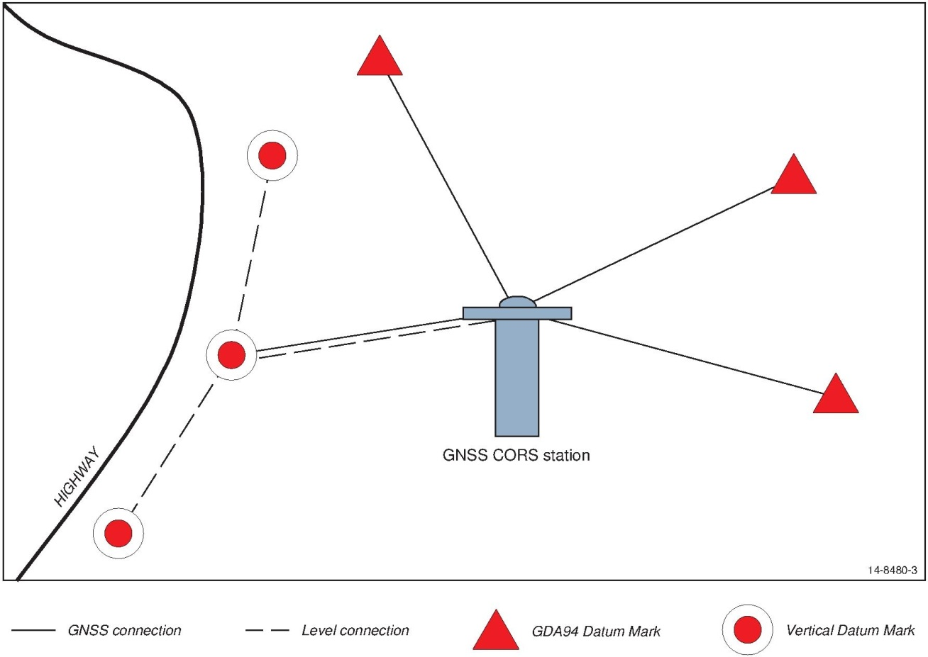

Figure : Connecting CORS sites with the survey control mark network

### Connection to GDA94

Once certified as described in Section 7.1, a CORS will be constrained in the datum adjustment and used to propagate GDA94 and PU to the surrounding survey control mark network. Therefore, undertake a Classic Static GNSS survey to a minimum of three survey control marks in the existing national and jurisdictional datum adjustment. Factors that influence the selection of suitable survey control marks include the existing PU estimate of the survey control mark, the number and quality of existing measurements between the survey control mark and other survey control marks in the datum adjustment, and the suitability of the survey control mark for GNSS observations. Note that the most suitable survey control marks for the propagation of PU may be many tens of kilometres from the CORS.

Design the PU propagation survey to achieve a Survey Uncertainty (SU) of better than 20 mm using the equipment, techniques, and processing procedures described in the *Guideline for Control Surveys by GNSS*. Twenty four hour occupation lengths on the survey control marks are recommended.

In the case where there is a considerable distance between the most suitable survey control marks and the CORS, undertake a similar Classic Static GNSS local survey to minimise the Relative Uncertainty (RU) between the CORS and local survey control marks. Select a minimum of three survey control marks from the existing national and jurisdictional datum adjustment. The factors that influence the selection of suitable survey control marks are the same as those chosen for the PU propagation survey. In this case, however, the survey control marks selected should be in close proximity to the CORS, bearing in mind that close proximity depends on the density of marks surrounding the CORS.

Design the local survey to achieve a SU of better than 20 mm using the equipment, techniques, and processing procedures described in the *Guideline for Control Surveys by GNSS*. Twenty four hour occupation lengths on the survey control marks are recommended. In this manner the RU between the CORS and the survey control mark network immediately surrounding the CORS will be minimised.

### Connection to Australian Height Datum

Connect the CORS station to a minimum of three nearby AHD marks. This connection survey should use the equipment, techniques and processes described in the *Guideline for Control Surveys by Differential Levelling* or *Guideline for Conventional Traverse Surveys* to achieve a RU of 10 mm or better.

Where the CORS antenna is already in place, or when determining height datum on the ARP directly is impractical such as where the CORS antenna is on top of a building, use differential levelling or a total station to determine height datum on a survey control mark within 100 m of the CORS.

A Classic Static GNSS survey can then be undertaken to determine an ellipsoidal height on this survey control mark, and to compute a derived AHD height of the CORS ARP using AUSGeoid. This GNSS connection should be designed to achieve an SU of better than 20 mm using the equipment, techniques, and processing procedures described in the *Guideline for Control Surveys by GNSS*.

## Regional and network monitoring

Regional monitoring involves sending regular data to an analysis centre to determine the movement of the CORS site relative to other CORS sites distributed across Australia. Geoscience Australia has established a mechanism for continual regional monitoring through the Asia-Pacific Reference Frame (APREF) project. APREF CORS will also contribute to maintenance and improved realisation of the national geodetic frame. For further information on regional monitoring and contributing CORS data to the APREF project please contact Geoscience Australia at [geodesy@ga.gov.au](mailto:geodesy@ga.gov.au).

In addition to independent regional monitoring, internal network monitoring is also recommended. Network monitoring relates to CORS that distribute data to a central control centre that operates CORS management software. Once satisfactory coordinates are assigned to the CORS sites, software modules monitor the relative position of the CORS sites in the network. The software can be configured to issue alarms or email warnings to network operators if relative movement of a CORS site outside a specified level is detected. This is recommended as the best method of monitoring CORS movement in real time, though the monitoring is limited to sites that are included in CORS network software.

# CORS operation

Tier 1 and 2 CORS contribute to international and national geodesy programs and must conform to the published requirements of those geodetic programs. The IGS site guidelines (IGS, 2013c) outline the operational requirements for Tier 1 CORS. Section 8 provides advice on the operational requirements of Tier 2 and 3 CORS.

## Operational status

CORS data users should be able to determine whether a CORS of interest is operating, was operating at a particular time, or is likely to be operating at a future time. Access to this information may be provided on a website that may also provide data access, outage notifications, site metadata, and other CORS related services.

When data from the CORS site is distributed to an analysis centre or real-time processing centre, the centre should be informed of any proposed changes to the site, and the scheduled timing of any outage, prior to the change or outage occurring. Once the change has occurred the analysis centre should be informed of the actual extent and timing of that change, and provided updated metadata and site logs. A similar communication process is recommended whenever an unscheduled outage occurs.

## Data reliability

The reliability of CORS data is a function of:

* stability of the ARP;
* signal tracking and data recording; and
* data transmission.

The stability of the Antenna Reference Point may be determined through the monitoring process outlined in Section 7.4 and through periodic surveys undertaken between the CORS and any reference marks that may be installed on the CORS site.

Table 6 provides recommended requirements for CORS observation and archival. The following definitions apply:

**Fully observed** means all available measurements on all available frequencies to all available satellites above the CORS elevation mask are recorded

**Available** assumes the GNSS receiver has sufficient and suitable tracking channels.

Conditions that may affect the interpretation of *available* include when an available GNSS satellite is deemed unhealthy and when the number of available GNSS satellites and/or signals exceeds the number of available tracking channels of the receiver.

Table : Recommended requirements for CORS reliability

|  |  |  |
| --- | --- | --- |
| **Criterion** | **Applies to** | **Recommended requirement** |
| Signal Tracking and Data Archival | Tier 1 and 2 | * 99.5% of the available epochs in each UT day are fully observed, recorded and archived, (corresponding to < 8 minutes of total outage per day). * 99.9% of the available epochs in a year are fully observed, recorded and archived (corresponding to < 9 hours of total outage per year). |
| Tier 3 | * 99% of the available epochs in each UT day are fully observed, recorded and archived (corresponding to < 15 minutes of total outage per day). * 99.5% of the available epochs in a year are fully observed, recorded and archived (corresponding to < 44 hours of total outage per year). |
| Data Transmission | Archived data | * Latency of an hourly data file for archival < 5 minutes after the end of the hour, * Latency of a daily data file for archival < 15 minutes from the end of the day. |

## GNSS data formats

### Post-processed data formats

Application of a proprietary GNSS data format may provide function and processing advantages suitable for in-house application where the downstream applications and technology are known to be compatible. It is recommended that GNSS data be archived in its original format.

Proprietary data formats, however, may not be able to be decoded by all end user software and equipment. For this reason, it is recommended that GNSS data for post-processing applications be available in the open standard Receiver INdependent EXchange (RINEX) or compact RINEX (Hatanaka) format. RINEX file specifications can be obtained from the IGS Formats web page (IGS, 2013d). Ensure that the information in the header of RINEX files is consistent with the information in the IGS site log and metadata. Use the standard naming convention for RINEX files as outlined in Section 4 of the RINEX file specifications.

### Real-time data formats

It is recommended that data for real-time GNSS services be made available in the Radio Technical Commission for Maritime Services – Special Committee 104 (RTCM-SC104) format, available from RTCM (2011). RTCM publishes global standards for the real-time transmission of GNSS data:

* RTCM 10402.3 RTCM Recommended Standards for Differential GNSS (Global Navigation Satellite System) Service Version 2.3. A standard used to distribute real-time differential GNSS data from a single reference station directly to a user.
* RTCM 10403.1 Differential GNSS (Global Navigation Satellite System) Services – Version 3 + Amendments 1, 2, and 3. A standard used to distribute real-time differential GNSS data including GNSS Network corrections to a user.
* RTCM 10410.1 Standard for Networked Transport of RTCM via Internet Protocol (NTRIP). A standard for transmitting RTCM 10403.1 and RTCM 10402.3 messages to multiple internet-enabled devices. Further information on NTRIP is available at the GNSS Data Centre NTRIP page.

RTCM 10402.3 messages are not compatible with RTCM 10403.1 messages. Older GNSS receivers designed for use with RTCM 10402.3 messages may not be able to derive a solution from RTCM 10403.1 messages. Therefore, both standards are being maintained as current standards.

## Meteorological and other sensor data

It is recommended that meteorological and other sensor data recorded at a CORS be archived in its original, or an open format, whichever is perceived to have the best long-term application. Where a meteorological sensor is connected to a GNSS receiver at a CORS, the meteorological sensor data may be able to be archived in RINEX format.

## Metadata

CORS metadata is the information about the site, including site ownership, contact details, monument information, tier status, the site coordinates, and their Positional Uncertainty. Reliable and current metadata is central to the management and use of a CORS, and is the responsibility of the CORS operator.

The IGS requires that all Tier 1 CORS record and maintain their metadata in an IGS site log, and that the site log is made available to the IGS and to all site users. An IGS site log template can be obtained from the IGS web site (IGS, 2013e).

Instructions on how to complete the site log are available from IGS (2013f). An advantage of the IGS site log is that historical information about a site is recorded in a single file.

It is recommended that an IGS site log be completed and published for all CORS sites to provide a consistent method of distributing relevant site metadata to analysis centres and users. A CORS operator may need to keep additional metadata, including a DOMES number where applicable, for the site to aid internal management and operation of the site.

The IGS site log refers to a 4-character identifier in its metadata requirements. This identifier must be unique to the site, and is usually chosen to represent the suburb, town or locality of the site. The GNSS operator should check with Geoscience Australia that the proposed four-character identifier for a new CORS site is not in use by another CORS. A non-exhaustive list of current and past 4-character identifiers for CORS sites can be obtained from the SOPAC (2013).

A national, state, or territory jurisdiction may have additional metadata requirements for CORS that connect to their survey control network. Contact the relevant jurisdiction for additional information.