ICSM works to: develop national reference material

Consistent Use of Place Names
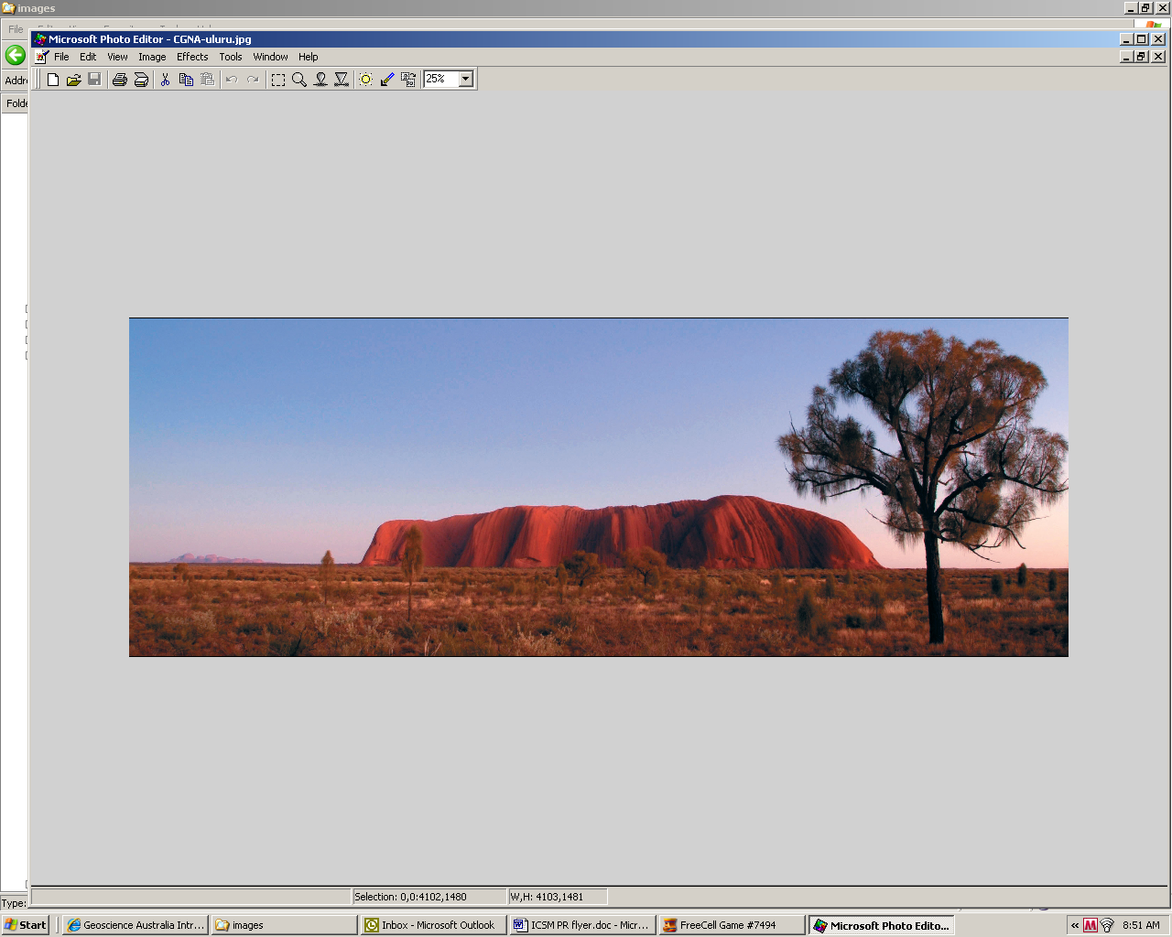
This ICSM Guideline provides nationally consistent and practical advice and for naming geographic features.
It includes a Section relating to:
- the Use of Indigenous Place Names
- Dual Naming (Indigenous and European)
This is a regionally significant document and it provides guidelines for the consistent recording of traditional indigenous names (Aboriginal and Torres Strait Islander and Maori) alongside introduced European names.
See http://www.icsm.gov.au/cgna/achievements.html

Digital Elevation Data
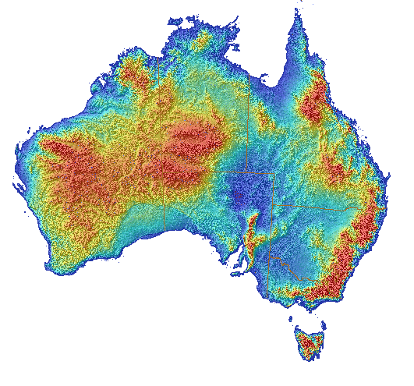
The purpose of this document is to provide consistent guidelines and recommendations for acquiring elevation data depicting the Earth’s surface – based on current best practice.
The guidelines were prepared under the auspices of the [Australian] National Elevation Data Framework (NEDF) initiative.
See http://www.icsm.gov.au/elevation/ICSM-GuidelinesDigitalElevationDataV1.pdf

Gazetteer of Australia
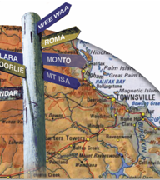
ICSM is very proud of this flagship product. It has created this from a number of very complex State/Territory gazetteers (officially approved geographic names) and a selection of other databases of unofficial geographic names.
It is a nationally consistent spatial database which contains 300,000 names. Features recorded include mountains, rivers, cities, towns and homesteads.
It can be viewed interactively at http://www.ga.gov.au/place-name/ or a complete copy of the data can be obtained from Geoscience Australia https://www.ga.gov.au/products/servlet/controller?event=GEOCAT_DETAILS&catno=71110.

Standards and Practices for Control Surveys
ICSM developed, and is continually up-dating, these nationally significant guidelines which provide:
- clear standards for the accuracy of control surveys – these are independent of technique; and
- a selection of guidelines for surveying and survey reduction practices
The latest version, 1.7 September 2007, can be viewed at http://www.icsm.gov.au/publications/sp1/sp1v1-7.pdf.

Topographic Map Index
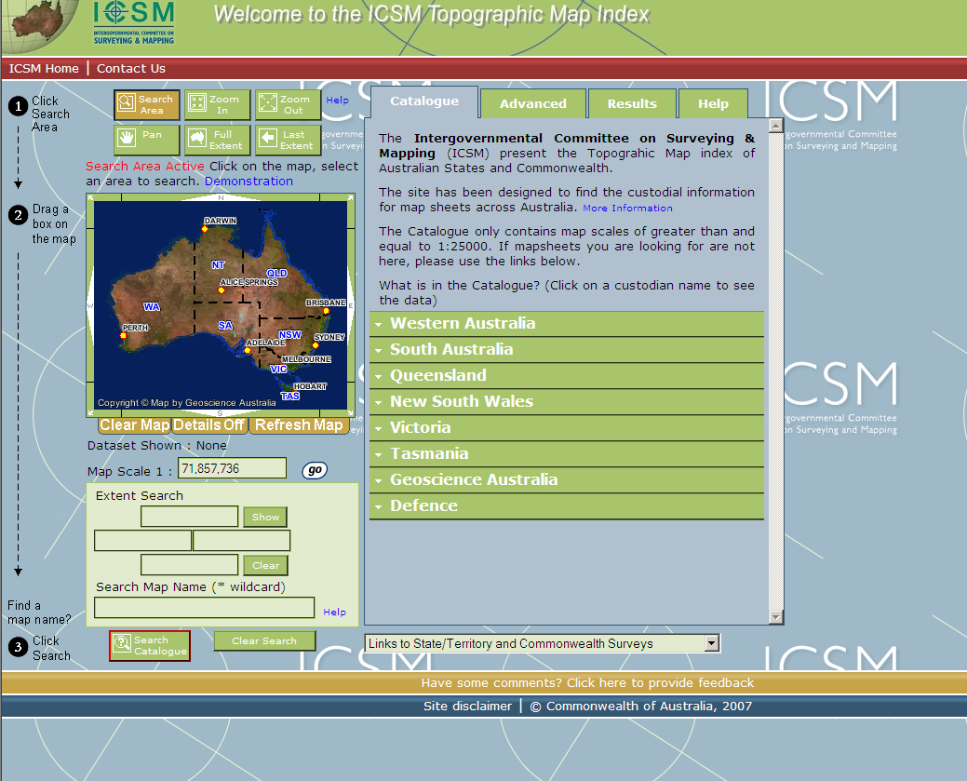
ICSM has developed a topographic map index for the whole of Australia.
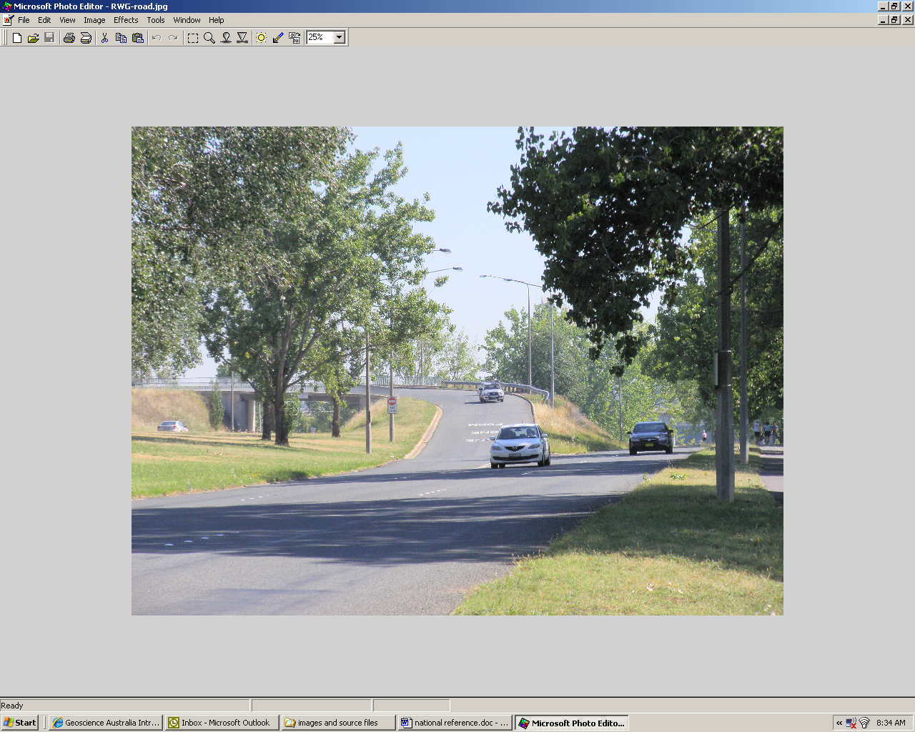
The Index provides up-to-date information about Commonwealth and State/Territory topographic mapping – regardless of which agency produced the map.
See http://www.icsm.gov.au/

Roads
The ICSM Roads Working Group has developed 2 nationally significant documents:
- A discussion paper on the options for developing a Nationally Consistent Road Classification System; and
- A Data Dictionary for national roads data sets
Both have proven to be very popular with web users
See http://www.icsm.gov.au/roads/index.html.

Intergovernmental Committee on Surveying & Mapping

Who We Are


We are the Intergovernmental Committee on Surveying & Mapping for Australia and New Zealand
(delegates to the ICSM meeting held in Melbourne, November 2009)
ICSM was established in 1988 by the heads of Australian governments – the Australian Prime Minister, State Premiers and Territory Chief Ministers. New Zealand joined in 1997.
Our Role is to provide leadership in the establishment of protocols and technical standards for national spatial information – including creating forums for information exchange.
We work in the area of
- topographic information – including elevation and imagery
- geodetic datums and coordinate systems
- land administration and cadastre
- place names
Contact
ICSM Secretariat
Lesley Waterhouse
ICSM Executive Officer
Geoscience Australia Building
Cnr Jerrabomberra Avenue and Hindmarsh Drive
SYMONSTON ACT 2609
GPO Box 378
CANBERRA ACT 2601
Phone: (02) 6249 9677
Mobile: 0419 694 669
Email: icsm@ga.gov.au
Website: http://www.icsm.gov.au/
- street addressing
- tides and hydrography

