

Guideline for Conventional Traverse Surveys

Special Publication 1

Version 2.1

Intergovernmental Committee on Surveying and Mapping (ICSM)

Permanent Committee on Geodesy (PCG)

24 September 2014

Document History

|  |  |  |  |  |
| --- | --- | --- | --- | --- |
| DATE | VERS | ISSUE | AMENDMENTS | AUTHOR(S) |
| 24/10/2013 | 2 | 0 | Document available | ICSM Permanent Committee on Geodesy |
| 24/09/2014 | 2 | 1 | Copyright update | ICSM Permanent Committee on Geodesy |
|  |  |  |  |  |

cid:image003.jpg@01CFCD16.091A3200

© Commonwealth of Australia (ICSM) 2014

With the exception of the ICSM logo and where otherwise noted, all material in this publication is provided under a Creative Commons Attribution 3.0 Australia Licence (<http://www.creativecommons.org/licenses/by/3.0/au/>)

Table of contents

Document History ii

Table of contents iii

List of figures iii

List of tables iii

Terms and definitions iv

1 About this Guideline 1

1.1 Introduction 1

1.2 Normative references 1

2 Connection to datum 3

3 Conventional traverse survey guidelines 3

3.1 Equipment 3

3.2 Survey procedures 5

4 Survey traverse uncertainty 6

5 Example test procedure 6

5.1 Survey uncertainty (SU) – minimally constrained least squares adjustment 7

5.2 Positional uncertainty (PU) – fully constrained least squares adjustment 9

5.3 Relative uncertainty (RU) – between survey control marks 10

5.4 Relative uncertainty – linear misclose ratio 11

List of figures

Figure 1: Conventional traverse survey example 7

Figure 2: Survey Uncertainty of the minimally constrained adjustment 8

Figure 3: Positional Uncertainty of the fully constrained adjustment 9

List of tables

Table 1: Equipment recommendations 4

Table 2: Observation techniques 5

Table 3: Estimated survey uncertainties (metres) 8

Table 4: Estimated positional uncertainties (metres) 9

Table 5: Estimated relative uncertainties (metres) 10

Table 6: Linear misclose assessment 11

Table 7: Linear misclose ratio lookup table 11

Terms and definitions

For the purpose of this Guideline, the terms and definitions listed below and those listed in the *Standard for the Australian Survey Control Network – Special Publication 1, Version 2.1* apply.

|  |  |
| --- | --- |
| Term/Acronym | Definition |
| Conventional | Based on or in accordance with what is generally done or believed. |
| EDM | Electronic Distance Measurement instrument that uses light or sound waves to measure distance. |
|  |  |

# About this Guideline

## Introduction

The availability of accurate and reliable information relating to the position and uncertainty of Australia’s survey control marks is critical to the integrity of the National Geospatial Reference System (NGRS). The purpose of this Guideline is to promote the adoption of uniform conventional traverse survey procedures to achieve the highest level of rigour and integrity in Australia’s survey control mark network.

There are several techniques available for determining the position of survey control marks. The technique adopted for a survey will depend on a number of factors, such as the required accuracy, the surrounding environment, the extent of the area to be covered, and the limitations and advantages of each technique.

This Guideline focuses on the establishment of survey control networks using conventional traverse surveys. The technique, conventional traverse surveying, when used to establish a survey control network is predominantly undertaken with a total station, or combined theodolite and Electronic Distance Meter (EDM). When conducting a control survey, this equipment is employed to measure a sequence of angles and distances, which are used to derive the position of survey control marks. The type of total station, ancillary equipment and surveying procedures all have a direct influence on the survey measurements and thus, the derived survey control mark positions and uncertainties.

This Guideline outlines ICSM’s recommended equipment and procedures for conventional traverse surveys, and provides examples for the evaluation of the uncertainty of estimated survey control mark coordinates.

## Normative references

This Guideline should be read in conjunction with the *Standard for the Australian Survey Control Network – Special Publication 1, Version 2.1,* herein referred to as the Standard.

The following documents may have relevance to the application of this Guideline.

**International Guidelines**

JCGM 100:2008, *Evaluation of Measurement Data – Guide to the Expression of Uncertainty in Measurement*, Joint Committee for Guides in Metrology – Bureau International des Poids et Mesures, Paris, France.

**SP1 Standard**

ICSM (2014), *Standard for the Australian Survey Control Network – Special Publication 1*, Version 2.1, Intergovernmental Committee on Surveying and Mapping, Canberra, Australia.

**SP1 Guidelines**

ICSM (2014), *Guideline for the Adjustment and Evaluation of Survey Control*, Version 2.1, Intergovernmental Committee on Surveying and Mapping, Canberra, Australia.

**ICSM Technical Manuals**

ICSM (2006), *Geocentric Datum of Australia Technical Manual,* Intergovernmental Committee on Surveying and Mapping, Canberra, Australia.

ICSM (2007), *Australian Tides Manual – Special Publication 9,* Intergovernmental Committee on Surveying and Mapping, Wollongong, Australia.

# Connection to datum

Survey control marks established for Australia’s NGRS shall be coordinated relative to the datums set out in Section 2 of the Standard.

# Conventional traverse survey guidelines

The equipment and procedures most appropriate for a control survey will largely depend on the desired quality of the final survey control mark positions. The following sections provide some guidance on conventional traverse surveys in relation to quality and provide recommended equipment and procedures for achieving various levels of Survey Uncertainty (SU) and Relative Uncertainty (RU). To achieve a desired Positional Uncertainty (PU) requires attention to both the uncertainty of the survey and the uncertainty of adopted datum stations. Examples of SU, RU and PU computations are provided in Section 5.

## Equipment

Total station instruments incorporate an EDM, which is used to measure direct distances, and an electronic theodolite which is used to measure horizontal and zenith angles between the instrument and target. There are many different types of total stations available, which are designed for a variety of different applications and precision requirements. There are also many different types of ancillary equipment (prisms, levelling and centring devices, tripods, etc) that are used with survey total stations. All total station instruments and ancillary equipment should be uniquely identified (e.g. via serial number) and calibrated on a regular basis.

Table 1 lists the recommended equipment recommendations to achieve varying levels of SU and RU.

Table 1: Equipment recommendations

|  |  |  |
| --- | --- | --- |
| **SU: < 2 mm**  **RU: < 2 mm or < 10 ppm** | **SU: < 10 mm**  **RU: < 10 mm or <30 ppm** | **SU: < 30 mm**  **RU: < 30 mm or <100 ppm** |
| EDM distance measuring accuracy: | | |
| ± 1 mm + 1.5 ppm | ± 3 mm + 3 ppm | ± 5 mm + 5 ppm |
| Angle measuring accuracy: | | |
| 1” | 5” | 10” |
| Instrument specific: | | |
| EDM instrument calibrated to national standard of length annually | | |
| Instrument corrections applied (index and scale corrections) | | |
| Reflector additive constant applied | | |
| Reflectorless EDM should not be used to measure to survey control marks | | |
| EDM Automatic Target Recognition (ATR) functionality acceptable | | |
| 1st velocity atmospheric correction applied: | | |
| Yes | | N/A |
| Atmospheric measurement device accuracy: | | |
| T = 1o C, P = 1 mb, H = 2% | | N/A |
| Prism: | | |
| Precision prism, centring accuracy 0.5 mm | Circular prism, centring accuracy 1 mm | Prism, centring accuracy 2 mm |
| Tribrach and carrier: | | |
| Precision carrier with optical plummet, plummet accuracy 0.5 mm at 1.5 metre | Tribrach with optical plummet, or laser plummet | |
| Tripod: | | |
| Heavy duty, wooden, good condition | Good condition | |

## Survey procedures

For the establishment of survey control, Table 2 lists the recommended survey procedures to achieve varying levels of SU and RU.

Table 2: Observation techniques

|  |  |  |
| --- | --- | --- |
| **SU: < 2 mm**  **RU: < 2 mm or < 10 ppm** | **SU: < 10 mm**  **RU: < 10 mm or <30 ppm** | **SU: < 30 mm**  **RU: < 30 mm or <100 ppm** |
| Survey specific: | | |
| Traditional survey traverse techniques – face left/face right, back sight/fore sight. | | |
| Level instrument and targets directly over survey control marks. | | |
| Height of instrument and targets measured. | | |
| Collimation test to be performed: | | |
| Daily | Weekly | |
| Number of rounds face left/face right: | | |
| 5 | 3 | 2 |
| Residual from mean of any angle should not exceed: | | |
| 5” | 10” | 20” |
| Minimum ground clearance: | | |
| 1.0 metre | 0.5 metre | |
| Atmospheric corrections: | | |
| Atmospherics recorded at 1 hour intervals or pronounced changes in conditions. | | N/A |
| Atmospherics either entered into instrument or applied in processing stages. | | N/A |

# Survey traverse uncertainty

Like any surveying technique, the uncertainty of a conventional survey traverse will directly propagate into the final survey control mark coordinate uncertainty. This uncertainty is attributable to network design, the number of instrument setups, the measurement procedures employed and the travelled distance. For many conventional traverse surveys, the SU and RU should be examined to evaluate the quality of the survey.

Least squares adjustment should be used where possible to estimate survey control mark coordinates and SU, PU and RU. Please refer to the Standard and the *Guideline for the Adjustment and Evaluation of Survey Control* for the adjustment of survey control and the evaluation of survey measurements and coordinate uncertainty.

In circumstances where least squares adjustment is not used, RU should be estimated using other reliable statistical methods. Analysis of the linear misclose in a conventional control traverse survey may be used to assess the RU.

# Example test procedure

Consider a survey conducted around a city block to establish two new survey control marks (CITY3 and CITY4) nearby two existing survey control marks (CITY1 and CITY2) with published coordinates and PU. The two new survey control mark coordinates are required to have a 10 mm circular confidence region or better.

The equipment and field procedures listed for 10 mm SU and RU, as detailed in sections 3.1 and 3.2, are followed.

When connecting to datum, the PU of the control stations used should be less than the specified PU of the required survey coordinates.

Figure 1 displays the control survey observations and corresponding standard deviations. The uncertainty of the published coordinates is 6 mm (1σ) in both east and north directions. There are no estimates of PU available for the AHD heights of these survey control marks.

The following sections demonstrate the procedures for estimating coordinate uncertainty in regard to SU, PU and RU.

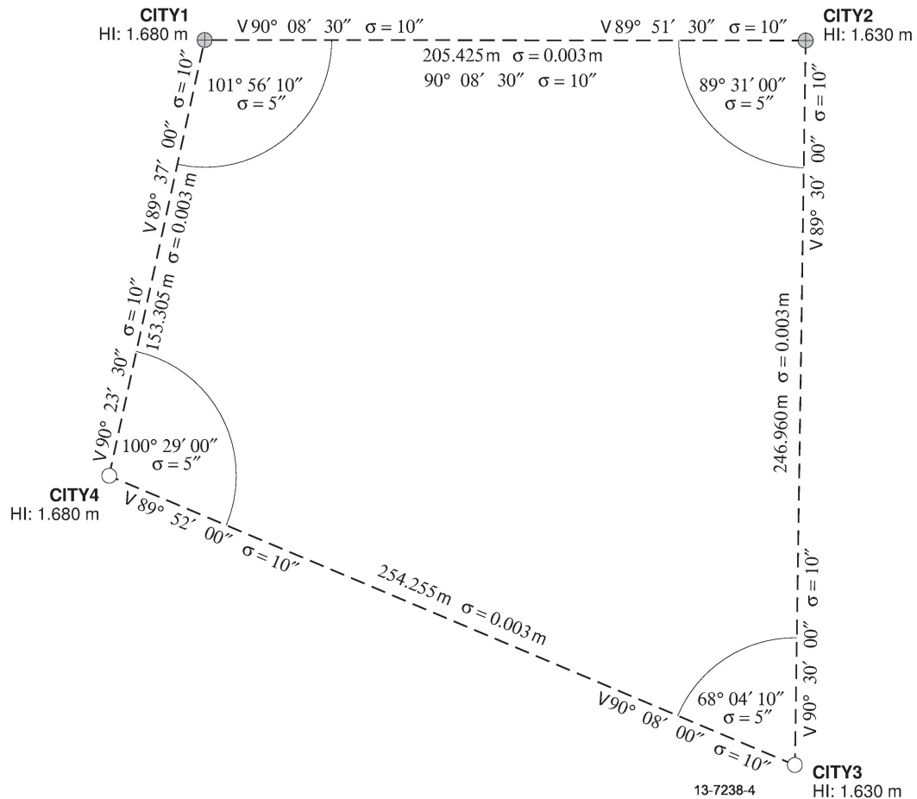

Figure 1: Conventional traverse survey example

## Survey uncertainty (SU) – minimally constrained least squares adjustment

To derive estimates of coordinate SU for the new survey control marks (CITY3 and CITY4), perform a minimally constrained least squares adjustment. In this example, survey control mark CITY1, and the north coordinate of CITY2 have been tightly constrained. The derived estimates of SU are shown in Figure 2 and Table 3 in terms of the standard error ellipse and circular confidence region at the 95% confidence level.

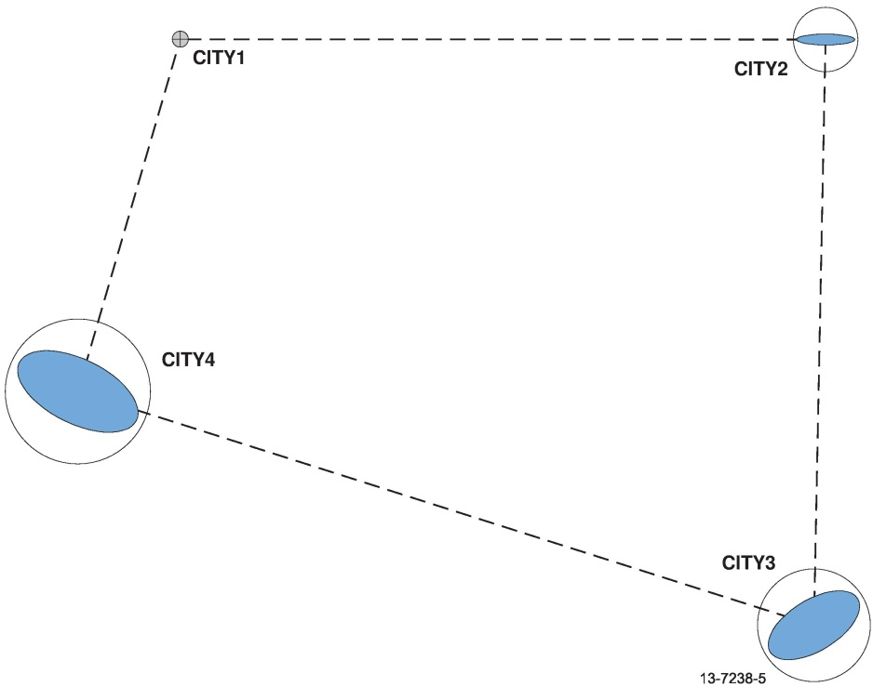

Figure 2: Survey Uncertainty of the minimally constrained adjustment

Table 3: Estimated survey uncertainties (metres)

|  |  |  |  |  |
| --- | --- | --- | --- | --- |
|  | Standard error ellipse (95%) | | | Circular confidence region (95%) |
| **Mark** | **Semi-major** | **Semi-minor** | **Height** |
| CITY1 | 0.000 | 0.000 | 0.000 | 0.000 |
| CITY2 | 0.004 | 0.000 | 0.012 | 0.004 |
| CITY3 | 0.008 | 0.004 | 0.015 | 0.009 |
| CITY4 | 0.007 | 0.004 | 0.010 | 0.007 |

The horizontal SU values are all less than 10 mm, satisfying the example recommendations. The vertical SU is greater than 10 mm. This indicates that if better than 10 mm vertical uncertainty is required for the new survey control marks, then the measurements to these marks will need to be repeated with a greater level of precision.

## Positional uncertainty (PU) – fully constrained least squares adjustment

To estimate PU for all survey control mark coordinates; perform a fully constrained least squares adjustment. In this example, CITY1 and CITY2 have been constrained in east and north by 6 mm (1σ) and 6 mm (1σ), respectively. The height component of CITY1 has been tightly constrained in the adjustment as there are no estimates of PU for the heights of the survey control marks. The estimates of PU are shown in Figure 3 and Table 4 in terms of the standard error ellipse and circular confidence region, at the 95% confidence level.

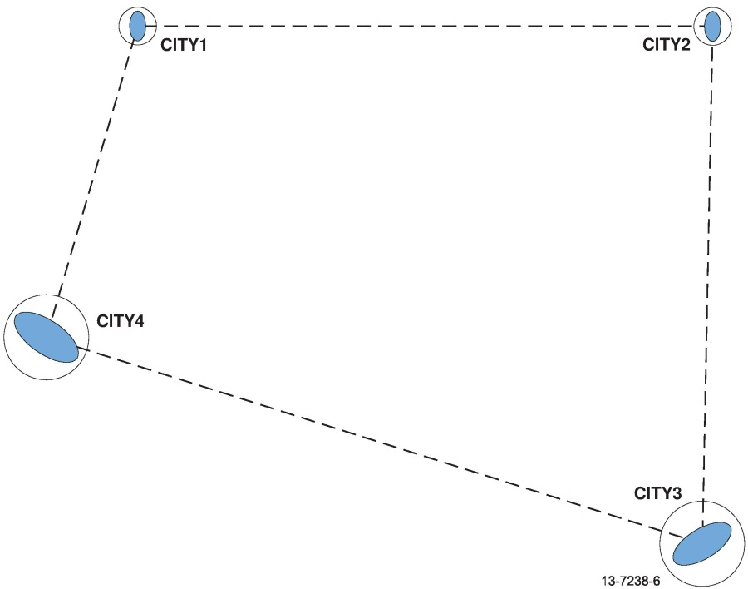

Figure 3: Positional Uncertainty of the fully constrained adjustment

Table 4: Estimated positional uncertainties (metres)

|  |  |  |  |
| --- | --- | --- | --- |
|  | Standard error ellipse (95%) | | Circular confidence region (95%) |
| **Mark** | **Semi-major** | **Semi-minor** |
| CITY1 | 0.012 | 0.007 | 0.013 |
| CITY2 | 0.012 | 0.007 | 0.013 |
| CITY3 | 0.024 | 0.010 | 0.025 |
| CITY4 | 0.019 | 0.010 | 0.020 |

Note that the PU values of all survey control marks are greater than 10 mm. This is due to the influence of the published PU of the established survey control marks (CITY1 and CITY2), and the SU on the network adjustment.

This adjustment demonstrates how to propagate uncertainty in the datum onto newly established survey control marks. To achieve the most rigorous estimation and testing of position and uncertainty, this survey should be included in an NGRS adjustment (State, Territory and Australian Government). However, for general purpose control surveys, no further computation is required.

## Relative uncertainty (RU) – between survey control marks

Estimates of the RU between any two survey control marks can be rigorously calculated from the coordinate uncertainties derived from a minimally or fully constrained adjustment. For this calculation, the full variance-covariance (VCV) matrix from the least squares adjustment is required.

To derive the 3D RU between survey control marks, copy the relevant VCV matrix elements into a (6 x 6) matrix (V) and prepare a (3 x 6) design matrix (A) as shown below.

$$A=\left[\begin{matrix}-1 & 0 & 0 \\ 0 & -1 & 0 \\ 0 & 0 & -1\end{matrix} \begin{matrix}1 & 0 & 0 \\ 0 & 1 & 0 \\ 0 & 0 & 1\end{matrix}\right]$$

The rigorous RU variance matrix (VR) can be obtained as follows:

$$V_{R}=AVA^{T}$$

A difference will exist in the RU estimates when derived from the minimally and fully constrained adjustments due to the influence of geometry and the uncertainty in the constraints. Table 5 displays the RU between all survey marks using the results from the minimally constrained adjustment.

Table 5: Estimated relative uncertainties (metres)

|  |  |  |  |  |  |
| --- | --- | --- | --- | --- | --- |
|  | | Standard deviation (95%) | | | Circular confidence region (95%) |
| **FROM** | **TO** | **Sd. E** | **Sd. N** | **Sd. H** |
| CITY1 | CITY2 | 0.004 | 0.000 | 0.012 | 0.004 |
| CITY1 | CITY3 | 0.009 | 0.004 | 0.015 | 0.009 |
| CITY1 | CITY4 | 0.007 | 0.005 | 0.010 | 0.007 |
| CITY2 | CITY3 | 0.009 | 0.004 | 0.014 | 0.009 |
| CITY2 | CITY4 | 0.007 | 0.005 | 0.014 | 0.007 |
| CITY3 | CITY4 | 0.005 | 0.006 | 0.014 | 0.007 |

## Relative uncertainty – linear misclose ratio

Another suitable means for evaluating the quality of a conventional survey traverse is to perform a linear misclose assessment. Both the two dimensional and three dimensional cases are shown in Table 6.

For a traverse, calculate the total surveyed distance using either the sum of the horizontal or slope distances depending on whether a 2D or 3D assessment is required. Calculate the linear amount by which the traverse miscloses in either two or three dimensions and then derive the linear misclose ratio in terms of parts per million (ppm). The ppm values (shown in Table 6) are less than 30 ppm, satisfying the recommendations of the Guideline.

Table 6: Linear misclose assessment

|  |  |  |  |
| --- | --- | --- | --- |
|  | Traverse distance (m) | Linear misclose (m) | Ratio (ppm) |
| 2D | 859.931 | 0.015 | 17.5 |
| 3D | 859.945 | 0.015 | 17.7 |

The ratio in ppm is calculated as follows:

$$Ratio=1,000,000* \frac{Misclose}{Distance}$$

To assist in evaluating the linear misclose ratio against the desired ppm values, Table 7 intersects the linear misclose ratio ppm values and various survey traverse distances to show the anticipated misclose.

Table 7: Linear misclose ratio lookup table

|  |  |  |  |
| --- | --- | --- | --- |
|  | Linear misclose ratio (ppm) | | |
| **Distance** | **10 ppm** | **30 ppm** | **100 ppm** |
| 100 m | 0.001 m | 0.003 m | 0.010 m |
| 200 m | 0.002 m | 0.006 m | 0.020 m |
| 400 m | 0.004 m | 0.012 m | 0.040 m |
| 500 m | 0.005 m | 0.015 m | 0.050 m |
| 800 m | 0.008 m | 0.024 m | 0.080 m |
| 1000 m | 0.010 m | 0.030 m | 0.100 m |
| 1500 m | 0.015 m | 0.045 m | 0.150 m |
| 2000 m | 0.020 m | 0.060 m | 0.200 m |