ANZ Metadata Working Group

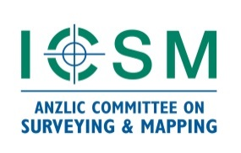
Meeting 11 Agenda

Date: 19-20 MAR 2024

Location: Virtual – MS Teams

Day 1: 19 MAR 2024
Time | Item Name
10:00 | Welcome and set up | MDWG Chair
 | Updates on International and National Standards activities
10:05  30 min | Update on ISO, OGC and UN GGIM work | Chris Body
10:35  20 min | Update on the ANZLIC/ICSM Technical MDWG activities | MDWG Chair/Byron Cochrane
10:55  20 min | Update on Vocab Symposium 2023 | MDWG Chair
11:15  15 min | Morning tea
11:30  25 min | GNSS Profile | Ivana Ivanova
11:55  25 min | Support for ISO 19115-3 XML | Vincent Fazio
12:20  30 min | ANZMET Lite v2 Plugin Proposal | Byron Cochrane
12:50  30 min | ICSM MDWG Draft Roadmap | MDWG Chair
13:20  10 min | Admin, summary | MDWG Chair

Day 2: 20 MAR 2024
Time | Item Name
10:00 | Welcome | MDWG Chair
10:05  60 min | ANZMet Lite Workshop | Byron Cochrane
11:05  5 min | Meeting closure | MDWG Chair

Microsoft Teams meeting
Join on your computer, mobile app or room device
Click here to join the meeting
Meeting ID: 483 343 089 407
Passcode: w9uUqf
Download Teams | Join on the web
Join with a video conferencing device
teams@vc.govteams.gov.au
Video Conference ID: 137 090 018 0
Alternative VTC instructions
Or call in (audio only)
+61 2 6188 4842,,903121928# Australia, Canberra
Phone Conference ID: 903 121 928#
Find a local number | Reset PIN

