How to access the ANZMet Lite v2 metadata tool

Getting Started:
Access the metadata tool via the link: https://atlas.metadata.ga.gov.au/geonetwork
For first time users, please accept the cookies for the metadata application.
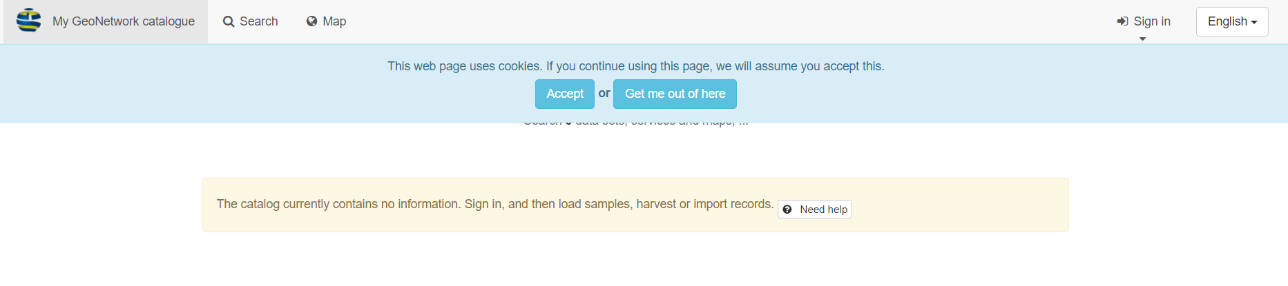

Signing In:
To sign in, please send ANZ_MDWG@ga.gov.au an email requesting a new user be added to the application.
Please send the following information to ensure the quickest method of access.
User name: (name to use when signing in)
First Name:
Surname:
Contact email:
Organisation:
Upon reply, you receive confirmation that User has been created with a temporary password which will need to be changed immediately for security reasons.
To sign in, the Sign In button is located on the top right of the application
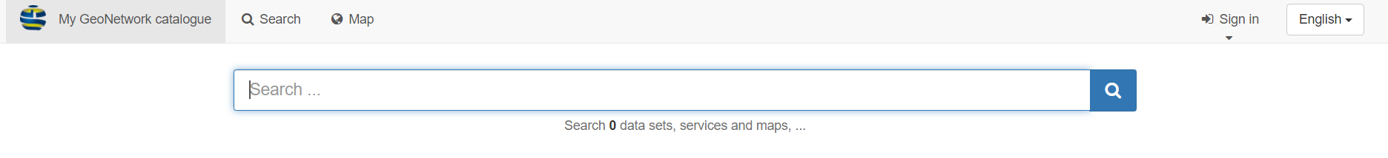
You can sign in by either hovering over the Sign in button or

By clicking on the Sign in button, which will transit you to the Sign in page.

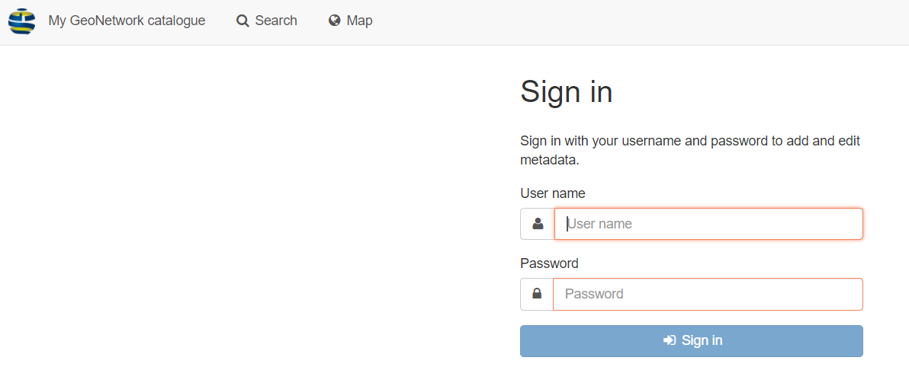
Through either method of Sign in, enter the User name and Password to gain access.
Resetting your password:
Once signed in, click on your profile on the top right of application
In the user profile window, click on your user
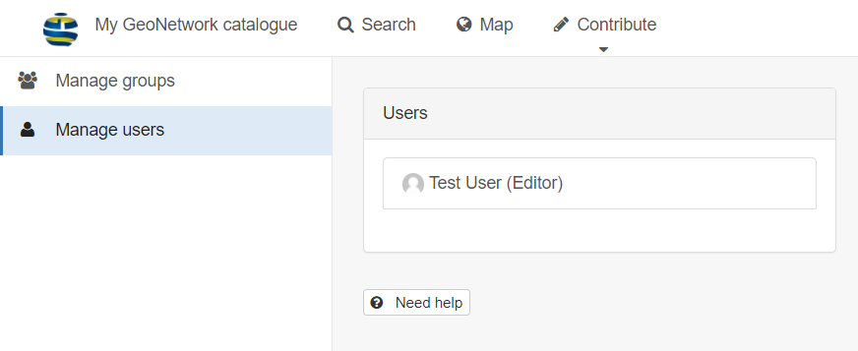

Click on the Reset password button (top right) to change from the defaulted set password. Please set the password to 8 characters in length with a capital letter and a number or numeric symbol.
Please verify all user information is valid and correct before clicking the Save button (top right)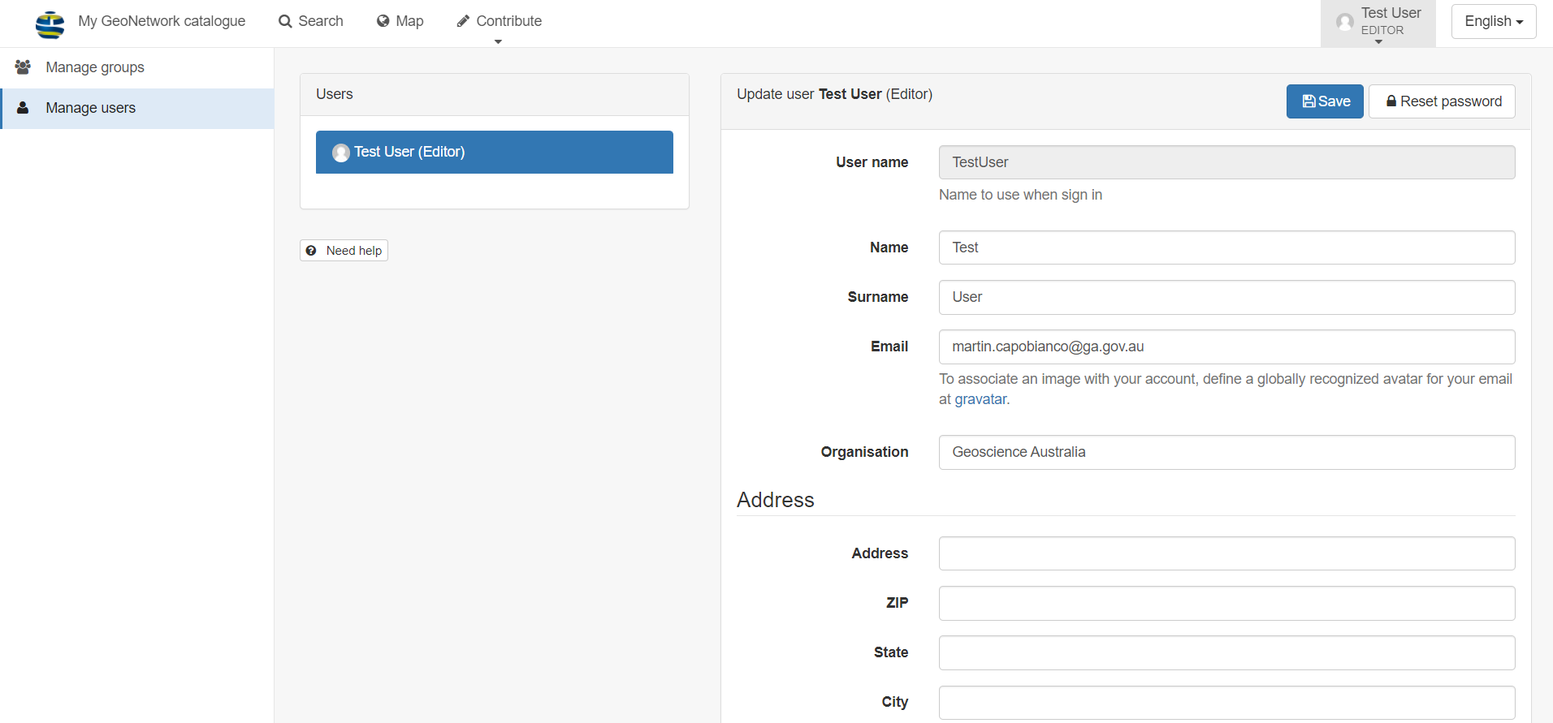

Creating a metadata record:
From any location in the application, hover over the Contribute menu (middle top of screen) and select Add new record

Once in the templates page, select the required template and hit the green Create button
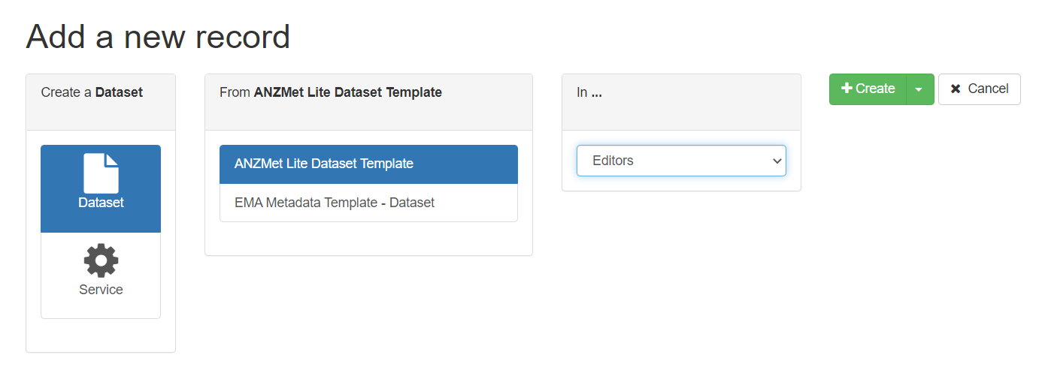

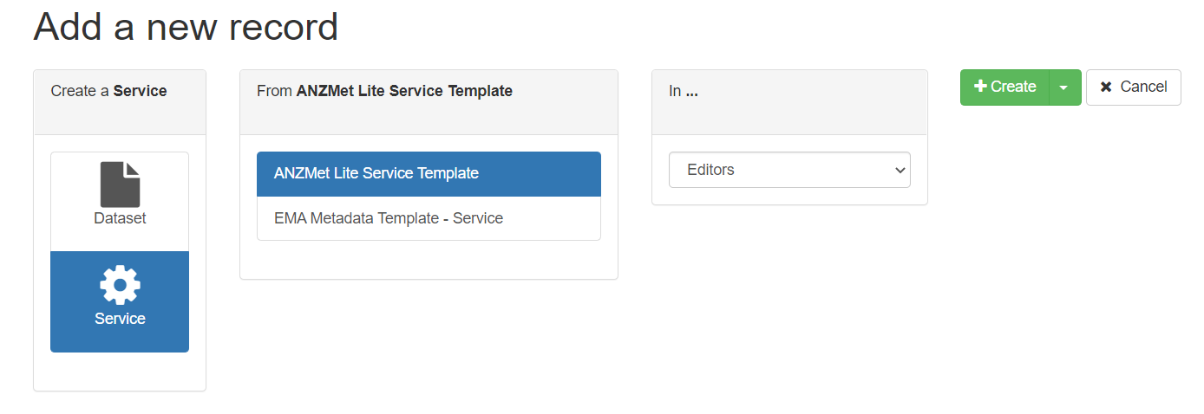
For more information and guidance on the metadata editor please visit:
For datasets: https://icsm-au.github.io/metadata-working-group/defs/TableOfContents.html
For services: https://icsm-au.github.io/metadata-working-group/defs/MetadataForServicesGuide.html

